**REPUBLIC OF CAMEROON**

PEACE-WORK-FATHERLAND

P.O. Box 63, Buea, South West Region CAMEROON Tel : (237) 3332 21 34/3332 26 90 Fax: (237) 3332 22 72

**FACULTY OF ENGINEERING AND TECHNOLOGY**

**DEPARTMENT OF COMPUTER ENGINEERING**



**DESIGN AND IMPLEMENTATION OF MARKET MANAGEMENT SYSTEM**

*A dissertation submitted to the Department of Computer Engineering, Faculty of Engineering and Technology, University of Buea, in Partial Fulfilment of the Requirements for the Award of Bachelor boof Engineering (B.Eng.) Degree in Computer Engineering*

**By:**

* **AMBE MBONG-NWI NCHANG**, Matriculation number **FE20A007**.
* **ASONGNA FRANK TONGWA**, Matriculation number **FE20A012**.
* **BESINGI NAURA MABOLA**, Matriculation number **FE20A023**.
* **FONGE BERTIN AMIN-SHU**, Matriculation number **FE20A040**.
* **NKWETAKEM TABO BRUNO**, Matriculation number **FE20A091**.

**Option**: Network & Software Engineering

**Supervisor**

Dr. NKEMENI VALERY

University of Buea

**2022/2023 Academic Year**

**DESIGN AND IMPLEMENTATION OF MARKET MANAGEMENT SYSTEM**

* **AMBE MBONG-NWI NCHANG**, Matriculation number **FE20A007**.
* **ASONGNA FRANK TONGWA**, Matriculation number **FE20A012**.
* **BESINGI NAURA MABOLA**, Matriculation number **FE20A023**.
* **FONGE BERTIN AMIN-SHU**, Matriculation number **FE20A040**.
* **NKWETAKEM TABO BRUNO**, Matriculation number **FE20A091**.

**2022/2023 Academic Year**

***Dissertation submitted in partial fulfilment of the Requirements for the award of Bachelor of Engineering (B.Eng.) Degree in Computer Engineering.***

**Department of Computer Engineering**

**Faculty of Engineering and Technology**

**University of Buea**

**CERTIFICATION OF ORIGINALITY**

We the undersigned, hereby certify that this dissertation entitled “**DESIGN AND IMPLEMENTATION OF MARKET MANAGEMENT SYSTEM**” presented by:

* **AMBE MBONG-NWI NCHANG**, Matriculation number **FE20A007**,
* **ASONGNA FRANK TONGWA**, Matriculation number **FE20A012**,
* **BESINGI NAURA MABOLA**, Matriculation number **FE20A023**,
* **FONGE BERTIN AMIN-SHU**, Matriculation number **FE20A040**,
* **NKWETAKEM TABO BRUNO**, Matriculation number **FE20A091**,

has been carried out by them in the Department of Computer Engineering, Faculty of Engineering and Technology, University of Buea under the supervision of **Prof/Dr/Mr/Mrs VALERY NKEMENI.**

This dissertation is authentic and represents the fruits of their own research and efforts.

Date__________________________

**Student Supervisor**

________________________________ ________________________________

**Head of Department**

Dr. ELIE FUTE

**DEDICATION**

This report is dedicated to every member of this group**, AMBE MBONG-NWI NCHANG, ASONGNA FRANK TONGWA**, **BESINGI NAURA MABOLA**, **FONGE BERTIN AMIN-SHU and NKWETAKEM TABO BRUNO** who have put in endless efforts to the realization of this project.

We would also like to dedicate this work to the University of Buea, which has provided us with an exceptional education and countless opportunities for personal and professional growth. Through the guidance and support of the faculty, staff, and peers, we have gained the knowledge and skills necessary to complete this project and pursue our goals with confidence and passion. We are also grateful to the University of Buea for fostering a culture of excellence, innovation, and service, and for instilling in us a deep sense of pride and gratitude for the privilege of being a member of this community. We hope that this work will serve as a testament to the values and vision of this University

**ACKNOWLEDGEMENTS**

We would like to express our sincere gratitude to all those who have contributed to the completion of this report. First and foremost, we would like to thank our lecturer, **Dr NKEMENI Valery**, for providing us with invaluable guidelines for the completion of the project. We are also grateful to all the experts and professionals who provided us with their time, insights, and expertise during the research and analysis phase.

We would like to extend our thanks to our classmates for their encouragement, feedback, and support during the writing process. We are also grateful to our families and friends for their unwavering support and encouragement, and for always being there for us throughout the ups and downs of this project.

**ABSTRACT**

The market management system is a comprehensive software solution designed to streamline and optimize various aspects of market operations. This research presents the development and implementation of a market management system tailored for small-scale local markets in the city of Buea, located in the South West region of Cameroon. The system aims to provide exposure for vendors and also ensure an easy and efficient goods purchase for buyers who visit the market.

This study adopts an agile development methodology, allowing for iterative and incremental software development. The system's key features include vendor and buyer registration and management, product upload, display and viewing, messaging, customer feedback collection, customer support, subscription and notification. The system is designed to be user-friendly, scalable, and adaptable to different market environments.

The research methodology involved gathering requirements through conducting market interviews and brainstorming. The system was developed using React Native and Django (mobile application development technologies), ensuring cross-platform accessibility and responsiveness.

This research contributes to the existing body of knowledge in market management systems and provides practical insights for market administrators and stakeholders interested in implementing similar solutions. Future enhancements may include integration with payment gateways, expansion to larger markets, and incorporation of advanced analytics and artificial intelligence algorithms.

**Table of Contents**

Title page ……………………………………………………………………………………1

Certification of originality……………………………………………………………………2

Dedication ……………………………………………………………………………………3

Acknowledgement ……………………………………………………………………………4

Abstract ………………………………………………………………………………………5

Table of Contents ……………………………………………………………………………..6

List of Tables ………………………………………………………………………………….7

List of Figures …………………………………………………………………………………7

CHAPTER 1. GENERAL INTRODUCTION………………………………………………...8

1. Background and Context of the Study

2. Problem statement

3. Objectives of the Study

3.1. General Objective

3.2. Specific Objectives

4. Proposed Methodology

5. Research Questions (if applicable)

6. Research Hypothesis (if applicable)

7. Significance of the Study

8. Scope of the Study

9. Delimitation of the Study

10. Definition of Keywords and Terms

11. Organization of the Dissertation

CHAPTER 2. LITERATURE REVIEW…………………………………………………14

1. Introduction

2. General Concepts on mobile apps for a market management system.

3. Related Works

4. Partial Conclusion

CHAPTER 3. ANALYSIS AND DESIGN …………………………………………………..16

1. Introduction

2. Proposed Methodology

3. Design

4. Global Architecture of the solution

5. Description of the resolution process

6. Partial conclusion

CHAPTER 4. IMPLEMENTATION (or REALIZATION) AND RESULTS

1. Introduction

2. Tools and Materials used

3. Description of the implementation process

4. Presentation and interpretation of results

5. Evaluation of the solution

6. Partial conclusion

CHAPTER 5. CONCLUSION AND FURTHER WORKS

1. Summary of findings

2. Contribution to engineering and technology

3. Recommendations

4. Difficulties encountered

5. Further works

References

Appendices

List of Tables

All found in the Appendix.

List of Figures

Fig 1: Context Diagram

Fig 2: Use Case Diagram

Fig 3: Class Diagram

Fig 4a: Login Sequence Diagram

Fig 4b: Subscription Sequence Diagram

Fig 4c: View Product Details Sequence Diagram

Fig 5: State Diagram

Fig 6: Activity Diagram

Fig 7: ER Diagram

Fig 8: Color Scheme

Fig 9: Typography

Fig 10a: Buyer Sign Up

Fig 10b: Forgot Password

Fig 10c: Seller Home Screen

Fig 10d: Product Catalog

Fig 10e: Messaging Screen

Fig 10f: Buyer Profile Screen

Fig 11a: Join Screen

Fig 11b: Error SignUp Screen1

Fig 11c: Error Sign Up Screen2

Fig 11d: Vendor Home Screen

Fig 11e: Vendor Order screen

Fig11f: Vendor Error Order Screen

Fig11g: Vendor Calculation Order Screen

Fig 11h: Messaging Screen

Fig 12a: Admin dashboard for local server

Fig 12b: Admin dashboard on render

Fig 12c: User Management

Fig 12d: Buyer Features

Fig 12e: Buyer Notification Features

Fig 12f: Buyer Messaging Features

Fig 12g: Buyer Rating Feature

Fig 12h: Seller Features

Fig 12i: Shop Creation

Fig 12j: product Management

Fig 12k: Subscription Feature

Fig 12l: Promotion Feature

Fig 12m: Seller Notification Features

Fig 12n: Seller Messaging Features

Fig 13a: Hosted backend on Render

Fig 13b: Activating the virtual environment

Fig 13c: Requirements

Fig 13d: Database Managing

Fig 14a: Testing and Notification Endpoint

Fig 14b: Testing the orders api endpoint

Fig 14c: Testing the products api endpoint

**CHAPTER 1: GENERAL INTRODUCTION**

* 1. **Background and Context of the Study**
     1. **Background of the Study:**

The city of Buea, located in the Southwest Region of Cameroon, is a bustling urban center known for its vibrant markets and diverse range of goods and services.

The background of the market management system in the city of Buea stems from the recognition of the importance of efficient market operations, improved vendor management, and enhanced customer experiences. The market plays a vital role in the lives of all individuals because it provides goods needed by buyers as well as provides a source of income for the various vendors selling these goods.

Manual processes and outdated systems have resulted in inefficiencies, delays, and limitations in effectively managing the markets. Again, we still find ourselves in situations where buyers wish to purchase goods but don’t know their locations and sellers have goods at cheap prices but few customers to buy.

Due to these challenges, there is a need for a market management system. A market management system is an application used by both customers and sellers where the customers can review the prices of certain items in the market, their availability and their location, whereas sellers can display their products, their prices and location in the market. This app helps both buyers and sellers in the following ways:

* The buyers are aware of the availability, prices, and location of their desired item before they visit the market by viewing the various item cards displayed in the system.
* Buyers can discuss with sellers on goods they wish to purchase so they can reserve the goods they wish to purchase.
* The sellers have more exposure and can attract the right customers to their shades by displaying their goods using cards
* Customer support present also helps both buyers and sellers in case of any problems.

**Context of the Study:**

The context of the market management system in Buea includes understanding the specific market dynamics, such as the different types of markets present (e.g., food markets, craft markets, clothing markets) and the cultural and social significance of these markets within the community. It acknowledges the need for efficient market operations, streamlined vendor management, and effective communication channels between market organisers, vendors, and customers.

Additionally, the market management system will include features to promote customer engagement and enhance the overall market experience. This includes the cards which display the available goods and their information to ease purchase, messaging where the customer can directly talk to the seller to reserve goods they wish to later purchase. The system will also support market promotions, advertising, and event management to attract a larger customer base and create a vibrant market atmosphere. It will facilitate efficient inventory management, allowing vendors to easily track and manage their stock.

In conclusion, the market management system in the city of Buea aims to address the specific challenges and requirements of the local market ecosystem. It is designed to streamline operations, enhance vendor and customer experiences, and support the growth and sustainability of the markets in Buea. By embracing technology and tailored solutions, the system will contribute to the vibrancy, accessibility, and economic success of Buea's markets.

1. **Problem Statement**

The city of Buea, located in the Southwest Region of Cameroon, is home to bustling markets that play a vital role in the local economy. However, these markets face various challenges that hinder their efficient management and optimal functioning. Manual processes, lack of exposure and knowledge result in inefficiencies, inadequate communication, and below-par experiences for both vendors and customers.

One of the key problems on the buyer side is that most buyers don’t know where certain items are located in the market and so may end up not buying what they came for.

Secondly, buyers may know where some products are located but will still not buy those goods due to their high prices. This is disadvantageous because those same goods might be available at another location in the market with a cheaper price.

Furthermore, buyers may be aware of the products, their locations and prices but will not know the amount of products left to be purchased.

On the seller's side, they may have products they wish to sell at cheap products but lack exposure, hence have only a few customers who purchase the goods leading to low income, and wastage of goods in cases where raw goods get spoiled.

Overall, the market management system seeks to overcome the challenges faced by Beau's markets, empower market organisers with efficient tools, provide vendors and customers with reliable and convenient market experiences, and contribute to the economic growth and development of the local market ecosystem.

1. **Objectives of the Study**
   1. **General Objectives**

* Enhance the overall management and efficiency of the markets in the city of Buea.
* Improve the vendor and customer experiences within the markets.
* Foster sustainable growth and development of the local market ecosystem.
* Promote transparency, fairness, and accountability in market operations.
* Support the local economy by empowering local businesses and entrepreneurs.
  1. **Specific Objectives**
* Implement features and functionalities that enhance customer engagement, item cards, personalised recommendations, and promotions to create a positive and immersive market experience.
* Provide real-time market information to vendors and customers, including operating hours, market locations, and products.
* Availability, to enhance convenience and facilitate informed decision-making.
* Establish effective communication channels between market vendors, and customers to facilitate timely announcements, updates, and feedback.
* Ensure fair market practices, prevent unauthorised activities, and enforce market regulations to maintain a level playing field for all vendors.
* Facilitate collaboration and networking opportunities among vendors and market stakeholders to foster a sense of community and promote knowledge sharing.
* Enhance the market's visibility and attractiveness through targeted marketing initiatives, advertising, and event management.

1. **Proposed Methodology**

The development methodology used is the **Agile** approach.

Agile methodology is an iterative and incremental approach to project management and software development. It emphasises flexibility, collaboration, and continuous improvement to deliver high-quality products and services. Agile methods promote adaptive planning, evolutionary development, early delivery, and continuous customer involvement.

Below are the various steps we used in this methodology

* **Project Initiation:** We defined the project vision, objectives, and scope. Identified the key stakeholders and formed the project team. Established initial requirements and created the product backlog.
* **Sprint Planning:** We selected a set of user tasks from the product backlog for the upcoming sprint. Defined the sprint goal and determined the specific tasks required to achieve it. Estimated the effort and complexity of each task.
* **Sprint Execution:** We worked on the selected tasks during the sprint, following the principles of iterative and incremental development. Collaborated closely with the supervisor and
* each other ensuring continuous communication and feedback.
* **Frequent Stand-up Meetings:** We conducted short frequent meetings at least twice each week to synchronise the team's progress, discussed any challenges or impediments, and ensured alignment. Each team member shared updates on their work since the last meeting and their plans for the coming period..
* **Continuous Development and Testing:** We continuously developed and tested the features and functionality during the sprint. We did early and frequent testing to identify and address issues promptly. We also maintained a sustainable pace of work to ensure quality and avoid burnout.
* **Sprint Review:** At the end of the sprint, we held a sprint review meeting to demonstrate the completed work to the supervisor. Gathered his feedback, addressed any questions or concerns, and determined whether the sprint goals have been achieved.
* **Sprint Retrospective:** We conducted a sprint retrospective meeting to reflect on the team's performance and identify areas for improvement. Discussed what went well, what could have been done better, and defined actionable steps to enhance the team's effectiveness in future sprints.
* **Backlog Refinement:** We continually refine and prioritised the product backlog based on new insights, supervisor feedback, and changing requirements. Collaborated with the supervisor to add, remove, or reprioritize user stories as necessary.
* **Repeat Sprints:** We repeated the sprint cycle, with each sprint typically lasting one week. Continuously delivered increments of the product, incorporating feedback and making adjustments along the way.
* **Project Closure:** Once the desired project goals had been met, we conducted a final review with the supervisor for evaluation and consequent grading.

1. **Research Questions**

The following questions were asked to buyers about difficulties faced when in the market.

* What are the key challenges you face as a buyer in traditional market setups that you believe a market management system could address?
* What specific features or functionalities would you like to see in a market management system that would enhance your shopping experience?
* How important is it for you to have access to real-time information about vendor availability, product availability, and pricing in a market management system?
* What level of convenience and ease of use do you expect from a market management system in terms of browsing products, making purchases, and tracking orders?
* How would you prefer to receive notifications or updates from the market management system regarding new products, promotions, or changes in vendor locations?
* What security measures or assurances would you like to see in place to protect your personal information and financial transactions when using a market management system?
* How likely are you to adopt and use a market management system on a regular basis, and what factors would influence your decision?
* What level of trust do you require in the market management system to feel confident in making purchases and conducting transactions?
* Are there any concerns or reservations you have regarding the use of a market management system? If so, what are they?
* How do you envision a market management system benefiting both buyers and vendors in terms of convenience, efficiency, and overall market experience?

The following questions were asked to sellers about difficulties faced when in the market.

* What are the main challenges you face as a seller in traditional market setups that you believe a market management system could help overcome?
* What specific features or functionalities would you like to see in a market management system that would benefit your business operations and sales?
* How important is it for you to have a centralised platform for managing inventory, tracking sales, and monitoring product performance in a market management system?
* What level of ease and convenience do you expect from a market management system in terms of listing and managing your products, communicating with buyers, and processing orders?
* How would you prefer to receive notifications or updates from the market management system regarding new orders, customer inquiries, or changes in market policies?
* What level of control and flexibility do you expect to have in setting prices, managing discounts or promotions, and controlling product availability within a market management system?
* How likely are you to adopt and use a market management system on a regular basis, and what factors would influence your decision?
* What security measures or assurances would you like to see in place to protect your business information, financial transactions, and customer data when using a market management system?
* Are there any concerns or reservations you have regarding the use of a market management system? If so, what are they?
* How do you envision a market management system benefiting both sellers and buyers in terms of expanding your customer reach, streamlining operations, and overall market growth?

1. **Research Hypothesis**

* The implementation of a market management system will lead to higher vendor satisfaction compared to traditional market setups.
* The adoption of a market management system is positively correlated with increased customer engagement and sales for vendors.
* The implementation of a market management system will improve the efficiency and effectiveness of inventory management for vendors.
* The implementation of a market management system is associated with an increase in the number of customers visiting the market.
* Customers will experience higher satisfaction and improved shopping experience when utilising a market management system compared to traditional market setups.

1. **Significance of the Study**

* **Improved Market Efficiency:** The study demonstrates the significance of implementing a market management system in enhancing the overall efficiency of market operations. By streamlining processes such as inventory management, order processing, and vendor communication, the system enables vendors to operate more smoothly, reducing administrative burdens and saving time.
* **Enhanced Customer Experience:** The study highlights the positive impact of the market management system on customer experience. Through features such as real-time product availability, convenient purchasing options, and personalised recommendations, the system enhances the overall shopping experience for customers, leading to higher satisfaction levels and increased customer loyalty.
* **Increased Vendor Profitability:** The findings of the study reveal that the implementation of the market management system contributes to increased vendor profitability. By providing tools for effective inventory management, pricing strategies, and customer engagement, the system empowers vendors to make data-driven decisions that optimise sales and maximise profits.
* **Facilitated Market Growth:** The study underscores the significance of the market management system in facilitating market growth. By attracting more vendors and customers, promoting fair competition, and enabling efficient transactions, the system creates a favourable environment for market expansion. This, in turn, contributes to economic growth and development in the local market ecosystem.
* **Informed Decision-Making:** The study provides valuable insights and data that can inform decision-making processes for market organisers, policymakers, and other stakeholders. The findings can guide strategic planning, resource allocation, and policy formulation related to the management and future development of the market.
* **Scalability and Adaptability:** The study demonstrates the scalability and adaptability of the market management system. By examining its successful implementation and utilisation in the specific market context, the study provides evidence of the system's potential for replication and adaptation in other markets, sectors, or regions.
* **Innovation and Technological Advancement:** The study highlights the significance of technological innovation in market management. By embracing a digital solution like the market management system, the market demonstrates its commitment to staying at the forefront of technological advancements, fostering innovation, and embracing modern business practices.

1. **Scope of the Study**

**Project Objective:** The objective of this market management system is to provide a medium where the customers can review the prices of certain items in the market, their availability and their location, whereas sellers can display their products, their prices and location in the market.

* **Deliverables:**
  + Mobile-based market management system accessible to authorized users.
  + Vendor management module for registration, onboarding, and profile management.
  + Inventory management module to track and manage product availability and pricing.
  + User authentication and access control functionality.
* **Inclusions:**
  + User-friendly interface with intuitive navigation and responsive design.
  + Integration with existing market infrastructure and systems.
  + Vendor registration and approval workflows.
  + Real-time inventory tracking and notifications.
  + Customizable dashboards and analytics for data visualisation.
* **Exclusions:**
  + Online marketplace functionality for e-commerce transactions.
  + Physical infrastructure and hardware installations.
  + Integration with external payment gateways.
  + Web application development.
* **Constraints:**
  + Project budget of XAF 0.
  + Development timeline of 4 months.
  + Limited resources with a development team of five members.
  + Availability of market data and information for integration.
* **Assumptions:**
  + Market stakeholders will provide necessary data and cooperation for system implementation.
  + Market vendors will be trained on system usage and compliance.
  + The market management system will comply with relevant data privacy and security regulations.
* **Dependencies:**
  + Cooperation and support from market administrators and stakeholders.
* **Stakeholders:**
  + Project Supervisor
  + Development Team: Developers, Designers, Database Administrators
  + Market Vendors, and buyers.

1. **Delimitation of the Study**

* **Time:** The study was conducted for three and a half months namely: March, April, May, and June.
* **Geography:** The study was focused on the markets located in the city of Buea in the South West region of Cameroon.
* **Population:** The research was targeted at market sellers and buyers, all within the age range of 15 to 60 years.
* **Methodology:** The study was done using interviews (quantitative) of buyers and sellers and brainstorming (qualitative) amongst team members.
* **Variables:** The study was focused on the products to be sold, their prices, quantity and location in the market.

1. **Definition of Keywords and Terms**

* **Marketing Portal**: A marketing portal is an online software meant to help facilitate electronic market(trading) management and provide for electronic display and review of various goods, their prices, and locations.
* **Buyer:** A person who makes a purchase
* **Seller:** A person who exchanges her goods and services for a form of payment like money.
* **Product:** A product is a tangible or intangible item or service that is created, designed, or manufactured to fulfil a specific need or want of customers. It can be a physical object, such as a consumer product like foodstuffs or it can be an intangible offering, such as hair service, a digital service, or a consulting service.
* **Price of a product:** The price of a product refers to the monetary value assigned to it in exchange for its ownership or use
* **Location of a product:** Location refers to the physical or virtual place where a product is made available for customers to purchase or access.
* **Availability of a Product:** The availability of a product refers to its accessibility or presence in the marketplace for customers to purchase or use.
* **Sprint:** In the context of Agile methodology, a sprint is a time-boxed iteration during which a development team works on a set of predefined tasks or user stories. It is a short, focused period of work which lasted a week as we implemented the project.

**CHAPTER 2: LITERATURE OVERVIEW**

1. **Introduction.**

Mobile apps have become an essential tool for many businesses and consumers in various domains, such as e-commerce, education, health care, entertainment, and more. Mobile apps can provide various benefits, such as convenience, accessibility, personalization, interactivity, and engagement. One of the domains that can benefit from mobile apps is the market management system, which is a system that connects buyers and sellers in a physical market place.

A market management system can help buyers find the best deals and sellers promote their products effectively. However, developing and implementing a mobile app for a market management system poses several challenges, such as user interface design, data security, network connectivity, scalability, and user satisfaction. In this literature review, we will explore the general concepts on mobile apps for a market management system, review some related works that have been done in this field, and provide a partial conclusion on the current state of the art and future directions.

1. **General Concepts on mobile apps for a market management system.**

A mobile app for a market management system is a software application that runs on a mobile device, such as a smartphone or a tablet, and allows users to access and manage information related to a physical marketplace. The main users of such an app are buyers and sellers who want to trade goods or services in the market. The app can provide various features for both types of users, such as:

* 1. **For buyers:**
* The app can allow buyers to search for products or services by keywords, categories, prices, ratings, reviews, availability, location and others.
* The app can also show buyers the best deals or offers from different sellers based on their preferences or location.
* The app can also enable buyers to compare products or services from different sellers based on various criteria, such as quality, price, delivery time, warranty and more.
* The app can also facilitate buyers to contact sellers directly via chat or call functions, or to place orders online and pay securely via various payment methods.
* The app can also provide buyers with notifications or reminders about their orders or deliveries, as well as feedback or rating options to share their opinions or experiences with other buyers or sellers.
  1. **For sellers:**
* The app can allow sellers to create and manage their profiles or stores on the app platform, where they can display their products or services with detailed information, such as descriptions, images, prices, availability, location and others.
* The app can also help sellers to optimise their pricing strategies based on market demand or competition analysis.
* The app can also enable sellers to communicate with buyers directly via chat or call functions, or to receive and process orders online and confirm payments via various payment methods.
* The app can also provide sellers with notifications or alerts about their orders or deliveries, as well as feedback or rating options to monitor their performance or reputation among buyers.

1. **Related Works.**

Several studies have been conducted on developing and evaluating mobile apps for a market management system in different contexts and scenarios. Here are three example:

* 1. **Kim et al. (2019)**: this paper was on a proposed a mobile app for a smart agricultural market management system that connects farmers and consumers in rural areas of South Korea. The app provides features such as product search, price comparison, order placement, payment confirmation, delivery tracking, feedback sharing, etc. The authors evaluated the app using usability testing and user satisfaction surveys and found that the app improved the convenience and efficiency of both farmers and consumers.
  2. **Liu et al. (2020)**: this paper talks of a developed mobile app for a smart campus market management system that connects students and staff in a university campus in China. The app provides features such as product recommendation, price negotiation, order confirmation, payment verification, delivery confirmation, feedback exchange, etc. The authors evaluated the app using system testing and user feedback analysis and found that the app enhanced the user experience and satisfaction of both students and staff.
  3. **Oyelere et al. (2020)**: this paper proposed a mobile app for a smart fish market management system that connects fish farmers and consumers in Nigeria. The app provides features such as product discovery, price comparison, order booking, payment processing, delivery arrangement, feedback collection, etc. The authors evaluated the app using prototype testing and user acceptance testing and found that the app increased the trust and loyalty of both fish farmers and consumers.
  4. **Alam et al. (2021)**: This paper explores the use of mobile apps for market management in the context of Bangladesh. The authors conducted a case study of a mobile app that was developed for farmers and consumers in the country. They found that the app had a number of benefits, including improving the efficiency of market transactions, reducing the cost of marketing, and increasing the transparency of the market.
  5. **Arunkumar and Manikandan (2020)**: This paper proposes a mobile app for a smart market management system for fruits and vegetables. The app provides features such as product search, price comparison, order placement, payment confirmation, and delivery tracking. The authors conducted a survey of farmers and consumers in India and found that there was a high demand for such an app.
  6. **Boateng and Otoo (2020)**: This paper describes the development of a mobile app for market management in Ghana. The app provides features such as product listing, price comparison, order placement, and payment processing. The authors evaluated the app using user testing and found that it was easy to use and met the needs of users.
  7. **Dahmash and Alzoubi (2021)**: This paper investigates the use of mobile apps for market management in Jordan. The authors conducted a survey of farmers and consumers in the country and found that there was a high demand for such apps. They also developed a prototype app and evaluated it using usability testing.

1. **Partial Conclusion.**

Mobile apps for a market management system can provide various benefits for both buyers and sellers in a physical market place, such as convenience, accessibility, personalization, interactivity, and engagement. However, developing and implementing such an app also involves several challenges, such as user interface design, data security, network connectivity, scalability, and user satisfaction.

**CHAPTER 3. ANALYSIS AND DESIGN**

* 1. **Introduction**

In today’s world as technology keeps expanding and as markets and businesses become highly competitive, there is the need for efficiently well analyzed and designed systems that can better manage and streamline various market operations such as sales, optimize market resources and maximize their profits. The purpose of this chapter is to show the analyzes and design that was done for a market management system that could better link various buyers and sellers found in our local markets, by making buyers know the best goods available for them in the market while on the other hand helping sellers increase their revenue as they have exposure to more customers

This chapter will focus mainly on the gathered requirements and analyses of existing market structures. We’ll also look at components of the system including the architecture, the different proposed methodologies, tools and technologies used in developing the system such as the user interfaces, the database. Moreover, the resolution of the design process will be talked about and lastly, the chapter will be will be ended with a conclusion.

* 1. **Analysis and Proposed Methodology**
     1. **Analysis**

Upon analyses of a market management system, a couple of perspectives were looked into so as develop a system that meets users’ needs.

* Product perspective

This system is meant to serve as a platform where the display and review of goods alongside their prices and locations can be carried out conveniently. Our goal is to develop a computerized system to aid in managing the buyer and seller activities and so increasing the overall efficiency of the Market.

* System Interface

System Interface means an electronic exchange of data between two or more systems to allow an efficient flow of information. The users will interact with the system via an interface produced using React Native, the operations will be performed by use of Django, and data in the system will be stored using Postegre SQL Database

* **User Interface**

This system shall provide a very intuitive and simple interface to the buyers and sellers so that the buyers can efficiently review goods and be aware of their availability, prices, and location before visiting the market. The sellers will also easily display their products and locations hence attracting the right customers to their shades.

* Hardware interface
* Server side

The application was hosted on a web server that is listening on the web standard port, receiving queries and processing them, and returning the appropriate response to the app.

* Client side

Mobile screen – the software shall display information to the user via their Mobile Screen. The software shall interact with the screen of the user and shall activate areas for data input, command buttons, select options from menus, and update the database.

* Software interface
* Server side

A Postegre SQL web server will accept all requests from the client and forward it accordingly. A database will be hosted centrally using PostegreSQL.

* Client side

An OS that is capable of running a modern app that supports react native.

* Communication interfaces
* A dashboard that allows users to monitor and control various aspects of the market, such as inventory, orders, customers, suppliers, …
* A notification interface that provides users with real-time notifications and alerts on market events
* A messaging interface that enables users to interact with the market vendors
* Tools Used

1. **React Native**: It was used to build the frontend because of the following reasons below:

* Supports IOS and Android users which covers all our targeted users
* Write once and use everywhere (code written can be used on any platform to build applications)
* Uses Javascript which has widespread usage and is also very popular
* Easy to use if you know javascript.
* Live reload (modify code and see modifications simultaneously)
* Strong community support
* Compatible plugins third-party packages
* Cost-efficient testing (provides few unit testing functionalities via Javascript frameworks and other third-party testing tools).
* It relies heavily on third-party applications and plugins

1. **Django:** This was used to build the backend because:

* It leverages the capabilities of python
* It is versatile and scalable
* It has a large community
* It is flexible
* It enables fast development
* It is very secure

1. **PostegreSQL** Relational Database for the database
2. **StarUML** for drawing the various UML diagrams
3. **Figma** for the UI/UX designs
   * 1. **Proposed Methodologies**

A couple of methodologies were come across while analyzing the system and basically 3 main methodologies were being used in building a system that could better link buyers and sellers with respect to the phase of development process. The methodologies used were agile methodology, the requirement analysis methodology and the UML language methodology

* **Agile Methodology**

This is a flexible an iterative approach to software development that emphasizes collaboration between developers, customers and stakeholders. It breaks down the development into smaller or more manageable sprints with each sprint focusing on delivering a particular functionality. This methodology was advantageous in that the development team could quickly respond to changing requirements and adapt the system over time

* **Requirement analysis Methodology**

This methodology involves gathering and analyzing the requirements of the market management system from stakeholders, buyers, sellers and other parties in the market system. This process helped in identifying the necessary features, the functionalities and the different integrations of the system

* **Unified Modelling Language(UML) Methodology**

This methodology is a visual modelling language consisting of a set of diagrams hat help system and software developers to visualize and document the artifacts of the software system. This methodology was therefore used to demonstrate the structure, the behavior and different interactions taking place in the system.

* 1. **Design**

This phase in the development focused on a couple of aspects which helped in building the system. These aspects were the system requirements, the system architecture and the user interface design

* + 1. **System Requirements**

This subsection details out what exactly the functional and non-functional requirements were for a mobile app that manages a market system

1. **Functional Requirements**

They describe what the system should do.In other words, a functional requirement describe a particular behavior of function of the system when certain conditions are met, for example: “Send email when a new customer signs up” or “Open a new account”. Here are the three stages that a functional requirement goes through when performing an action



* **Input:** This refers to any form of signal that makes the system behave in a particular way. For example, if a website allows a user to click on a link that takes them to another webpage, the act of clicking the link is the input.
* **System behavior:** This is a response to the input, and it defines how a functional requirement behaves. For example, a system behavior may include if software shuts down when detecting a potential security threat.
* **Output:** This is how the behavior effects software. For example, if the system behavior involves expanding more storage space, then the output includes more file space for users to save their data.

The functional requirements of our system were seen to be as as follows

* **Create Account:** Sellers and buyers can create accounts so that each users’ information can be easily managed and linked to them in the database. This also ensures security as they need to be authenticated before they log into these accounts.
* **View and Update Profiles:** Sellers can view and update their profiles like the goods available for sell, prices and location. Buyers are also allowed to view this display.
* **Product Catalog:**

The app shall have a product catalog that displays the available products in the market uploaded by sellers, allows buyers to go through the different products and their price lists, display detailed information about a selected product and provide browsing and searching options to see product details

* **Search facility:**

The app shall provide the ability for a buyer to make searches based on their location, search for vendors with lower or moderate prices, search for a particular product

* **Notification system:**

The app shall be able to notify the buyers of the newly added products in the market, the price increase or drop in products

* **Customer support:**

The app shall provide help to buyers and sellers, choose the support type they want, display FAQs upon request, provide a customer support contact number to call for urgent supports

* **Tax Calculations:**

The app shall be able to provide subscription plans for sellers be it weekly or monthly before they can broadcast their products

* **Rating system:**

The app will provide a rating mechanism for users to rate the sellers

* **A messaging system:**

The app will be able to allow buyers make negotiations with the sellers before they move to the market to purchase whatever product they want. This negotiation will be done through a one-on-one chat system in the app

1. **Non-functional requirements**

They specify **How** **the System Performs A Certain Function**. In other words, a non-functional requirement describes how a system should behave and what limits there are on its functionality.

Non-functional requirements focus on user **expectations,** as they are product properties**.**

For example, a system loads a webpage when someone clicks on a button. The related non-functional requirement specifies how fast the webpage must load. A delay in loading will create a negative user experience and poor quality of the system even though the functional requirement is fully met.

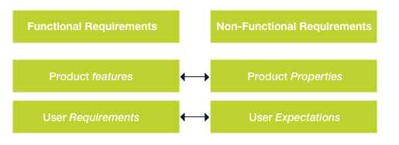

The system non-functional requirements are as follows

* **Usability:**

The app shall have a user-friendly graphical user interface (GUI) to allow sellers and buyers freely browse through

* **Performance:**

The app shall load quickly so as to respond to user actions promptly thereby preventing frustration on the app

* **Security:**

The app shall be secured enough to protect user data and prevent fraud

* **Scalability:**

The app shall be able to handle a large number of users especially when the price level of goods decreases.

* **Compatibility:**

The app shall be designed such that it is compatible with the different operating systems, be it Android or iOS and as well as responsive

* **Accessibility:**

The app shall be friendly for easy access

* **Reliability:**

The app shall be reliable and free from errors to prevent disruptions in service

* **Availability:**

The app shall be available to users both buyers and sellers 24/7 so as to easily access the app without difficulties

* **Manageability:**

The app will be designed such that it can be easily monitored by the administrators

* + 1. **System Architecture**

In this section, the UML methodology was applied and a couple of UML diagrams were drawn

* 1. **Types of UML Diagrams:**

There are two main categories which are:

* **Structural Diagrams:** Structural diagrams show the static structure of the system, such as the classes, objects, components, interfaces, and relationships among them.
* **Behavioral Diagrams:** They show the dynamic behavior of the system, such as the interactions, collaborations, state transitions, and activities of the system elements.
  1. **Diagrams Drawn for our Market Management System**

For our system, we have a **Context Diagram** and five (5) different UML diagrams and Entity Relationship diagram for the database which are:

* Use Case Diagram (Behavioral Diagram)
* Class Diagram (Structural Diagram)
* Sequence Diagram (Behavioral Diagram)
* State Diagram (Behavioral Diagram)
* Activity Diagram (Behavioral Diagram)
* The ER diagram
  1. **The different diagrams**
* **The context diagram**

This is NOT a UML diagram. It is a Level 0 data flow diagram that shows how a system interacts with external entities such as people, organizations, or other systems.

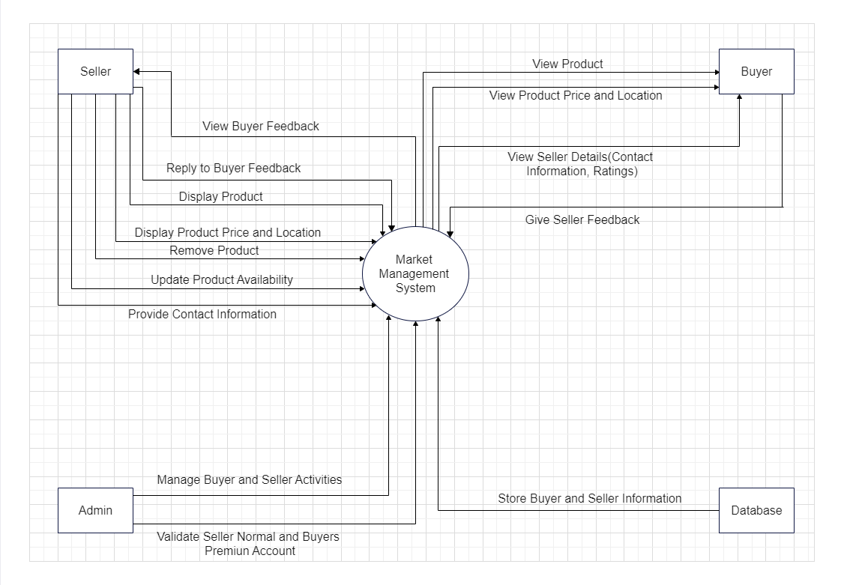

**Fig 1: Context Diagram**

* **Use Case Diagram**

This is the first diagram in the UML model. It helps us demonstrate users’ needs and consequently the expected behavior of the system. This diagram captures the functional requirements of the system from the perspective of the users and stakeholders. It shows the actors, use cases, and their relationships. It helps to define the scope and boundaries of the system and identify the main features and functionalities.

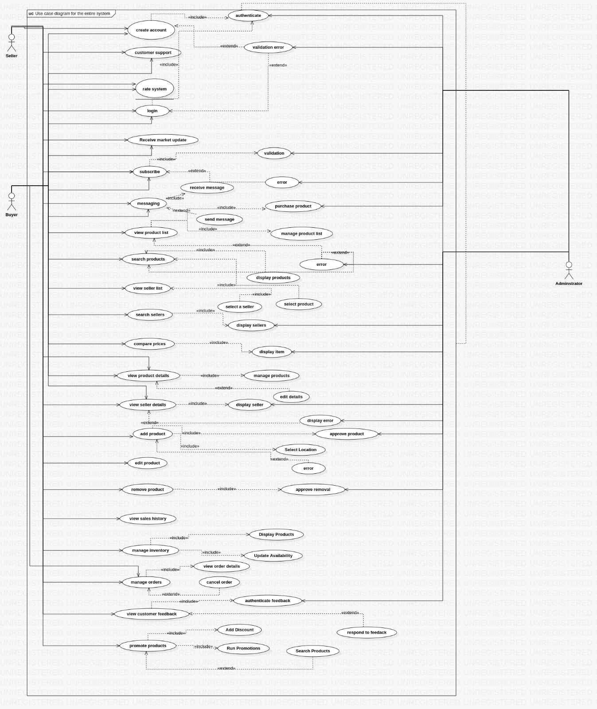

Fig 2: Use case diagram

* **Class Diagram**

This is the second diagram in the UML model. This diagram represents the static structure of the system in terms of classes, attributes, methods, and associations. It shows the logical organization of the system and how data and behavior are encapsulated and related. It helps to define the domain model and design the system architecture.

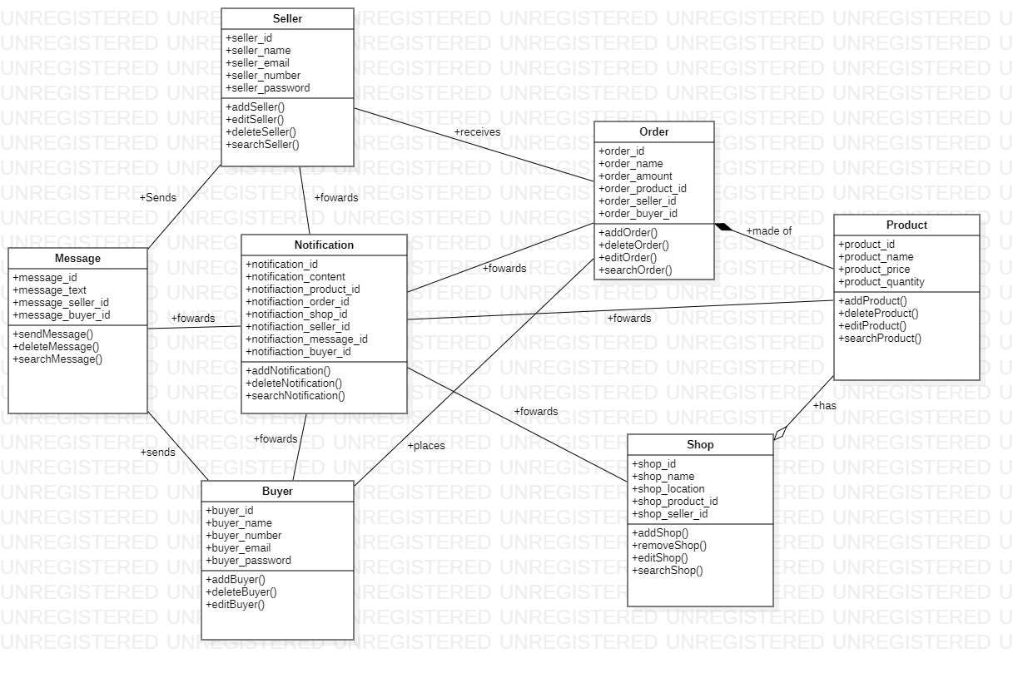

Fig 3: Class diagram

* **Sequence diagram**

This is the third diagram in the UML model. This diagram illustrates the dynamic behavior of the system in terms of interactions between objects over time. It shows the objects, messages, lifelines, and activation bars. It helps to describe how use cases are realized and how objects collaborate to achieve a goal.

Here, a sequence diagram was drawn for each of the 22 use cases as seen below:

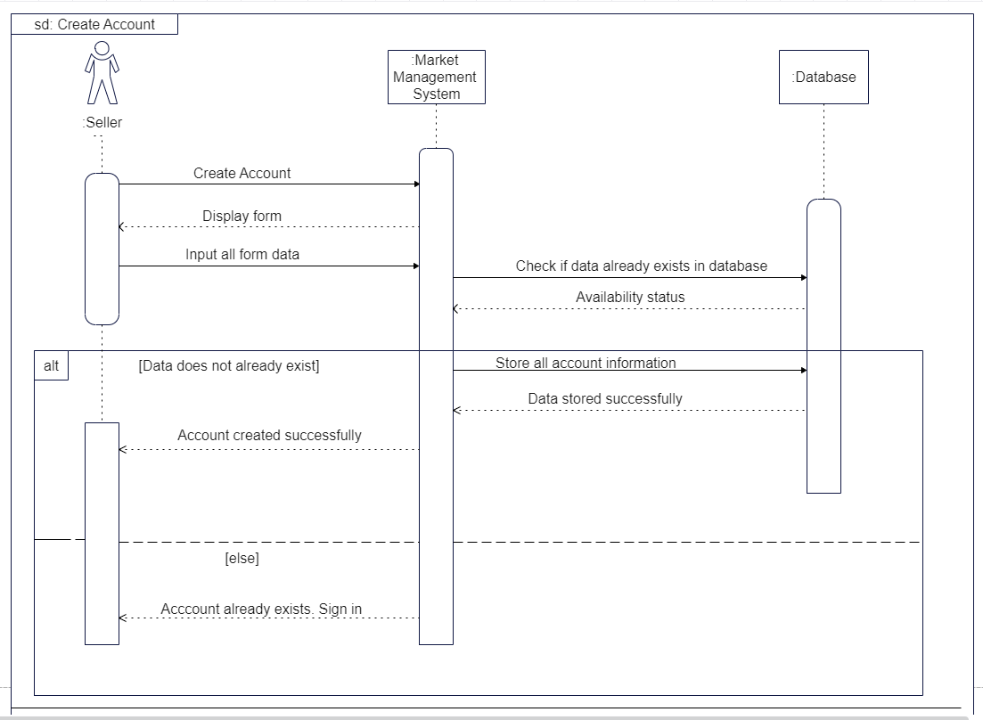

**Fig 4a: Login sequence diagram**

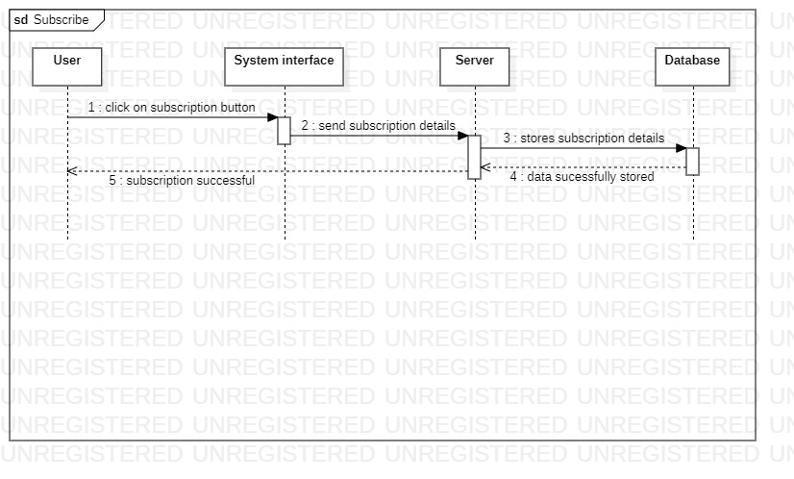

Fig 4b: Subscribe sequence diagram

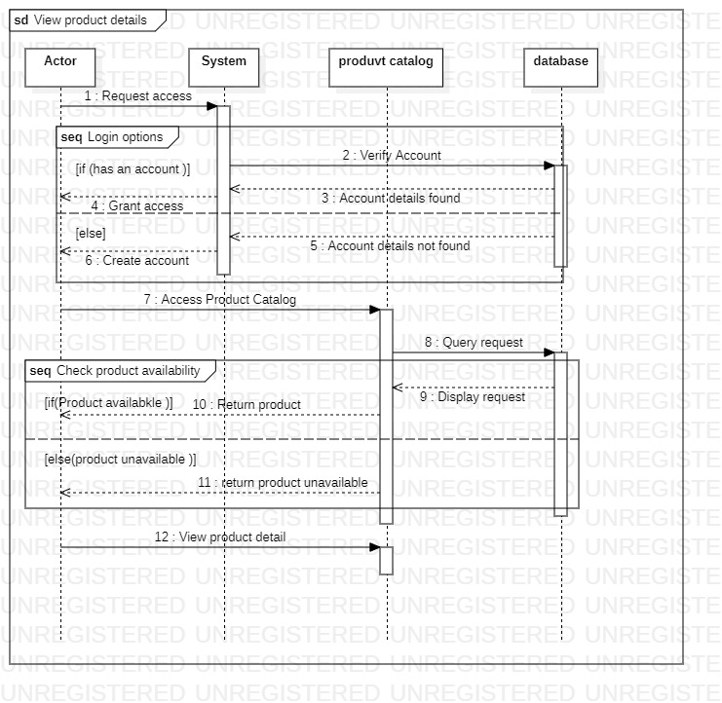

Fig 4c: view product details

* **State Diagram**

This is the fourth diagram in the UML model. This diagram depicts the dynamic behavior of an object or a part of the system in terms of states, transitions, events, and actions. It shows how an object changes its state in response to internal or external stimuli. It helps to specify the behavior and logic of an object or a subsystem.

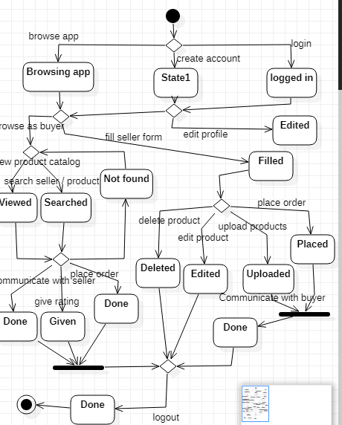

Fig 5: State diagram

* **Activity Diagram**

This diagram models the dynamic behavior of the system in terms of activities, actions, flows, and decisions. It shows how control and data flow through the system and how parallelism and synchronization are handled. It helps to represent workflows and business processes.

‘

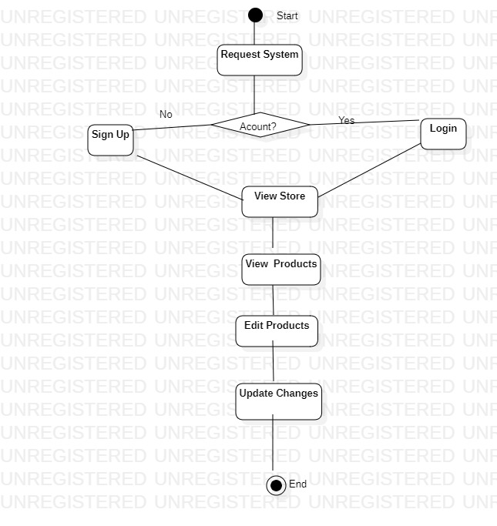

Fig 6: Activity diagram

* **ER Diagram**

An Entity-Relationship (ER) diagram is a graphical representation of the entities, attributes and relationships among data objects in a database.

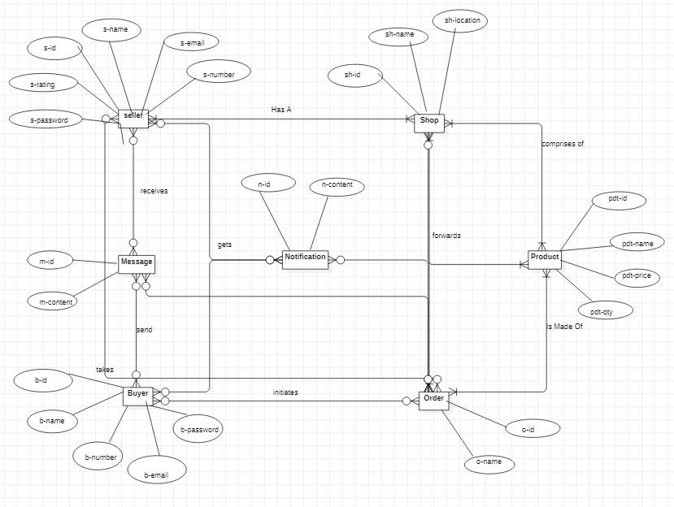

Fig7:ER diagram

* + 1. **User interface design**

The UI/UX design of the mobile application was carefully crafted to ensure a user-friendly and visually appealing experience for both buyers and sellers. The design focused on providing intuitive navigation, clear presentation of information, and seamless interactions. This section delves into the specifics of the UI/UX design, highlighting key features, interface components, and the overall user journey within the application.

1. **User Research and Analysis**

To ensure that the mobile application meets the needs and preferences of the target users, thorough user research and analysis were conducted. The following methods were employed to understand the requirements and expectations of both buyers and sellers:

**Interviews:** In-depth interviews were conducted with a select group of potential users, including both buyers and sellers. These interviews provided qualitative insights into their behaviors, motivations, and specific needs in the context of the marketplace.

The gathered data from user interviews was thoroughly analyzed and used to inform the UI/UX design decisions. The findings helped in identifying the key features and functionalities that would address the pain points of buyers and sellers effectively.

By conducting user research and analysis, the mobile application's UI/UX design and implementation were guided by a deep understanding of the target users' requirements and preferences. This approach ensures that the application is tailored to meet the needs of both buyers and sellers, facilitating efficient transactions and enhancing the overall user experience.

1. **Design pattern**

Moving on to the design pattern,the Z design pattern was used, which is a common approach in mobile app design that follows the natural reading and scanning patterns of users. It helps guide users' attention and optimize the presentation of important information.

Here's how the Z design pattern was applied in the design of the UI/UX

* **Buyer’s perspective**
* Home Screen: Display the most essential and relevant information to buyers upon opening the app. This can include popular or trending items, featured sellers, or personalized recommendations.
* Item Listings: Present the items for sale in a grid or list format, allowing buyers to quickly browse through the available items. Include key details such as title, price, availability, and location.
* Item Detail Page: Provide a comprehensive view of each item, showcasing high-quality images, detailed descriptions, seller information, and pricing. Include a prominent call-to-action for buyers to express interest or make a purchase.
* Location Mapping: Integrate a map feature to display the location of sellers in the market, allowing buyers to easily find and navigate to their desired sellers' locations.
* **Seller’s perspective**
* Seller Dashboard: Offer sellers a personalized dashboard that provides an overview of their product listings, sales, and customer interactions. Include features to manage listings, update prices, and monitor performance.
* Listing Management: Provide an intuitive interface for sellers to add, edit, or remove product listings. Include fields for title, description, pricing, availability, and location.
* Seller Profile: Allow sellers to create and customize their profiles, including information about their business, contact details, and any special offers or promotions.

1. **Visual Design**

In the design of our UI/UX we incorporated a clean and modern aesthetic, with a focus on simplicity and clarity.

* **Color scheme**

We decided to make use of green which tellers the nature of how most of our local markets look on market days. Below is the color layout used in the design of our applications UI/UX:

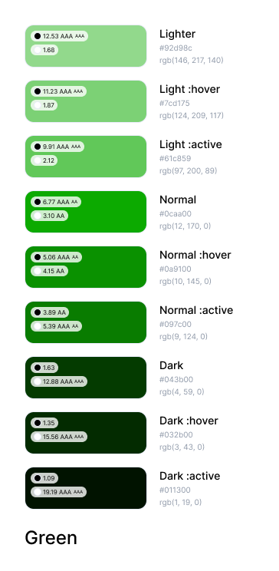

Fig 8: color scheme

* Typography

In the design and implementation of our applications UI/UX we decided to use montserrat and playfair light as our main fonts. These two fonts help us with legibility and visual hierarchy. They are also clear and easily readable fonts which are good for headings, titles, and body text, ensuring a comfortable reading experience for our users (buyers and sellers). Below is sample of our two fonts:

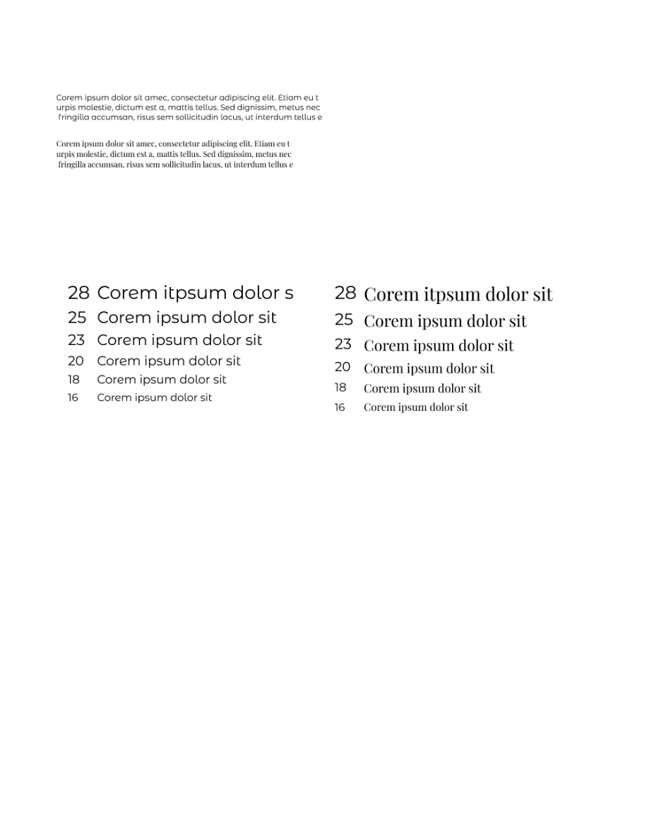

Fig 9: typography

1. **The Designed screens**

In designing the UI/UX , one of the most popular design tools, figma was used. Reasons being that it has the following

* Collaborative Design nature: Figma allows multiple designers to work together in real-time, promoting collaboration and efficient decision-making among designers, developers, and stakeholders.
* Cross-Platform Compatibility: Figma works seamlessly across different operating systems and devices, enabling designers to work on their preferred platform while ensuring compatibility and consistency when sharing design files.
* Interactive Prototyping: Designers can create interactive prototypes within Figma, defining app flow, interactions, and animations. This helps stakeholders visualize the user experience and provides a realistic preview of the final product.
* Plugins and Integrations: Figma supports a wide range of plugins and integrations, extending its functionality. Plugins automate tasks, provide additional design resources, and integrate with other tools and services to streamline the design workflow.

Below are the UI/UX designs for our application:

With the use of figma, the following screens were designed for the market management system

* + Signup screens

The sign up screens allow a new user (buyer and seller) create an account with the Carryam-GO app. They are required to fill a form which contains vital information about them. Once that is done, they’ll have the opportunity to browse through

* Forgot password screens

These screens allow an already signed up user to change their password in case they have forgotten. The users have the ability to verify themselves either through email or their inputted phone number from the time of signing up. Once verification is done, they can create a new password

* Home screen

Once users are signed in, they have the ability to to see the various products available in the market which are divides into **Top products** available in the market and the **Most affordable** which show thecheapest goods in the market

* Product Catalog

This screen displays the different goods according to categories. That is by the type of product sold in the market. Users can also find available discounts or goods on promotion and they can place an order

* Messaging

These screens allow the the buyers and sellers communicate. They can decide to discuss pricing on whatever good and arrive to a comprise by chatting on the chatbox

* Profile screens

They display personal information about the respective users of the system

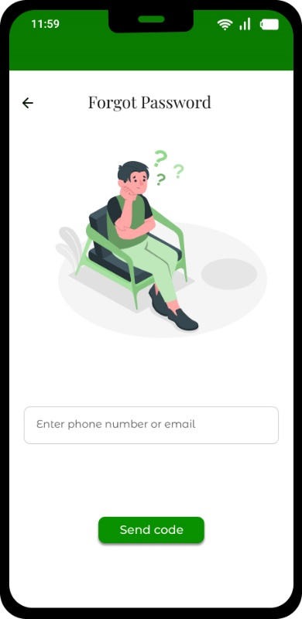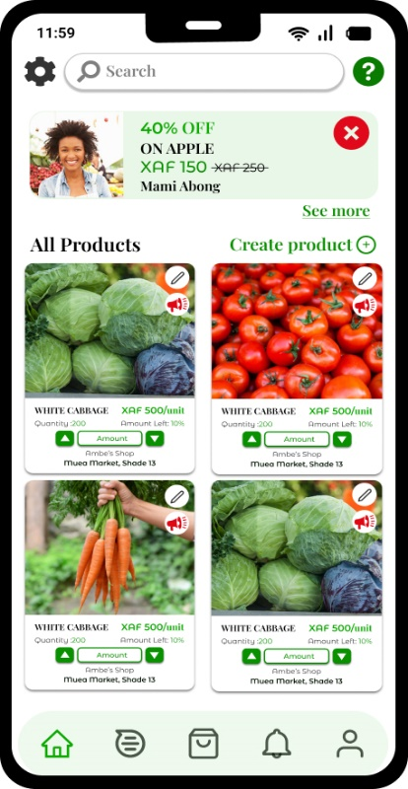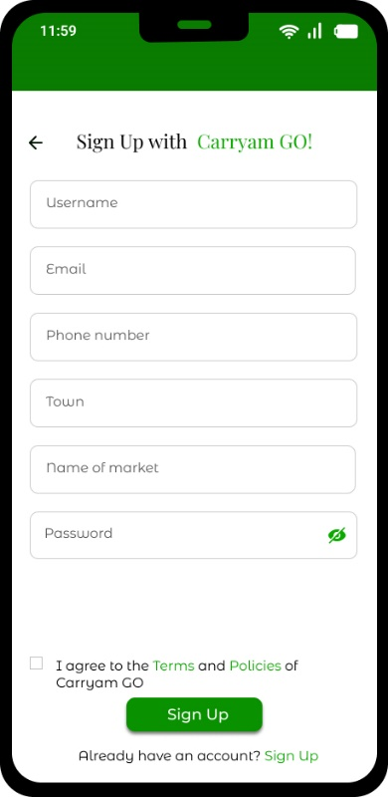fig 10a:buyer sign up fig10b: forgot password fig 10c: seller home screen

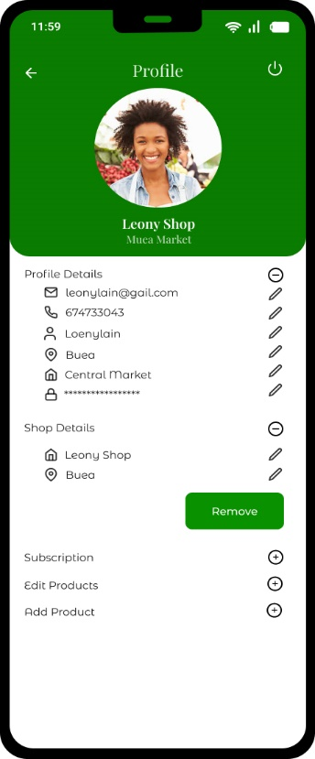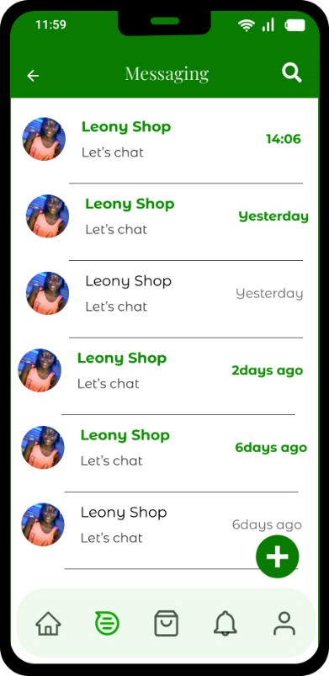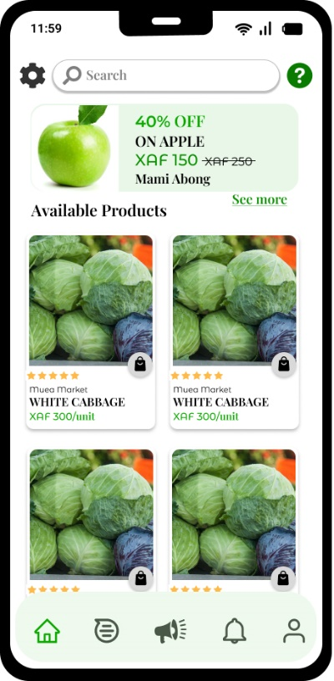

fig 10d: product catalog fig 10e: Messaging screen fig 10f: Buyer profile screen

* 1. **Global Architecture**
     1. System components

The system will have the following components:

* Frontend: The frontend is the user interface that customers and sellers will use to interact with the system. It will be a mobile app that can be used on smartphones and tablets.
* Backend: The backend is the data layer of the system. It will store all of the information about products, sellers, and customers. It will also be responsible for processing transactions and managing the system's features.
* API: The API is the interface that allows the frontend and backend to communicate with each other. It will be a RESTful API that is accessible over HTTP.
  + 1. System architecture

The system will be architected as a three-tier architecture. The frontend will be a single-page application that is hosted on a cloud platform. The backend will be a microservices architecture that is also hosted on a cloud platform. The API will be a RESTful API that is accessible over HTTP.

* + 1. System flow

The system will work as follows:

* Customers will use the frontend to search for products.
* The frontend will send a request to the API.
* The API will query the backend for the products that match the customer's search criteria.
* The API will return the results to the frontend.
* The frontend will display the results to the customer.

If the customer wants to buy a product, they will be able to place an order through the frontend. The frontend will send a request to the API, which will then forward the request to the backend. The backend will process the order and send a confirmation message to the customer.

* + 1. Security

The system will use a number of security measures to protect user data, including:

* HTTPS: All communication between the frontend and backend will be encrypted using HTTPS.
* Authentication: Users will be authenticated using OAuth 2.0.
* Authorization: Users will be authorized to access different features of the system based on their roles.
* Data encryption: User data will be encrypted at rest and in transit.

Overall, the global architecture of the Market Management System involves a user-friendly UI, authentication and authorization mechanisms, a robust database, API layer, integration with external services, security measures, scalability, and performance optimizations. These components work together to provide an efficient and user-centric market management solution for both buyers and sellers.

* 1. **Description of the resolution process**

The resolution process for the Market Management System involves the steps taken to address and fulfill the needs of both buyers and sellers. It focuses on ensuring that buyers have access to accurate information about product availability, prices, and location, while enabling sellers to effectively showcase their products and attract the right customers. The following description outlines the resolution process:

* User interaction
* Buyers interact with the application to search for specific items, view prices, and check their availability and location in the market
* Sellers utilize the app to display their products, set prices, and provide their location within the market.
* Information Retrieval:
* When a buyer searches for a particular item, the system retrieves information from the database regarding its availability, pricing, and location.
* The system ensures that the data presented to the buyer is accurate and up to date, reflecting real-time information.
* Presentation to Buyers:
* The retrieved information, including prices and availability, is presented to the buyer in a clear and organized manner through the user interface.
* Buyers can easily access and review the details of their desired items before visiting the market, enabling them to make informed decisions.
* Seller Product Showcase:
* Sellers utilize the app to showcase their products by uploading relevant details such as product images, descriptions, prices, and their location within the market.
* The system ensures that sellers have a user-friendly interface to manage and update their product listings.
* Matching Buyers and Sellers:
* The system employs algorithms and search mechanisms to match buyers' search queries with relevant products available from sellers.
* Buyers are presented with a list of products that match their search criteria, helping them find the right products and sellers attracting potential customers.
* Feedback and Ratings:
* The system allows buyers to provide feedback and ratings for products and sellers based on their experience.
* This feedback system helps buyers make informed decisions and encourages sellers to maintain quality products and services.
* Continuous Updates:
* The system regularly updates the product availability, prices, and location information based on changes provided by sellers.
* It ensures that buyers have access to the most accurate and reliable data when making purchasing decisions.
  1. **Partial Conclusion**

So far this chapter has provided a detailed analysis of the market management system, including the methodology used to gather and analyze the requirements, the system design, the global architecture of the solution, and the description of the resolution process. Through the proposed methodology, we were able to gain insights into the specific needs and requirements of the market, which informed the design of the system. The design of the system was based on the requirements identified during the analysis phase, and it was designed to meet the objectives of the system.

Also, the global architecture of the solution was carefully considered to ensure that the system could operate effectively and efficiently across different regions while meeting the specific requirements of each location. The resolution process was also described in detail, outlining the steps involved in resolving issues or conflicts between buyers and sellers.

**CHAPTER 4: IMPLEMENTATION AND RESULTS**

1. **Introduction**

The implementation was done in two main phases which are the Frontend and the Backend.

1. **Tools and Materials used:**

* ReactNative for the frontend
* Django for the backend
* PostgreSQL for the database
* Postman and TunderClient for testing API
* Render for deploying the backend

1. **Description of the Implementation Process**
   1. **FRONTEND IMPLEMENTATION**

### **Running the Project:**

### The expo-cli (command line interface) is a set of tools built around ReactNative. It was used as it abstracts away from the native code and makes it simpler to start developing in react by providing us a simpler development environment as well as utility features.

### To run project:

* Download project from github
* In terminal, run npm install to install the needed node modules
* Run npm start to start the project
* Download the expo app on your phone
* Scan the QR Code generated and preview the app on your phone.

### **React Native Components Used**

* **TouchableOpacity:** Used instead of button so it can be styled.
* **View:** Container view acts like a div
* **Text:** To display text to users
* **TextInput:** Enables users type in input using the default keyboard it provides
* **Switch:** Enables users accept or decline our policies at sign up page
* **ScrollView:** Used to enable scrolling on a page
* **Stylesheet:** Enables styling of components.
* Stack Navigation
* Bottom Tab Navigation
* Modal Navigation

### **Basic Element of the System**

Due to the modular nature of the system, we have the card as the basic element of the system.

**Card:** This component was created to display various products available in the market. It renders data from the API. When the API is fetched, the data is rendered and displayed in the cards through the props.

The cards contain the following:

* Picture of available food
* Food name, price
* Amount of that item available
* Shop name
* Market name
* Shade number
* The order button.
  + 1. **Presentation and Interpretation of Results**

From the images below, we can see that the system successfully implemented security and authentication via the login process by either a buyer or seller.

In cases where fields are left empty or wrong format of data entered, we get erroneous messages and are restricted from either logging or signing in as shown below:

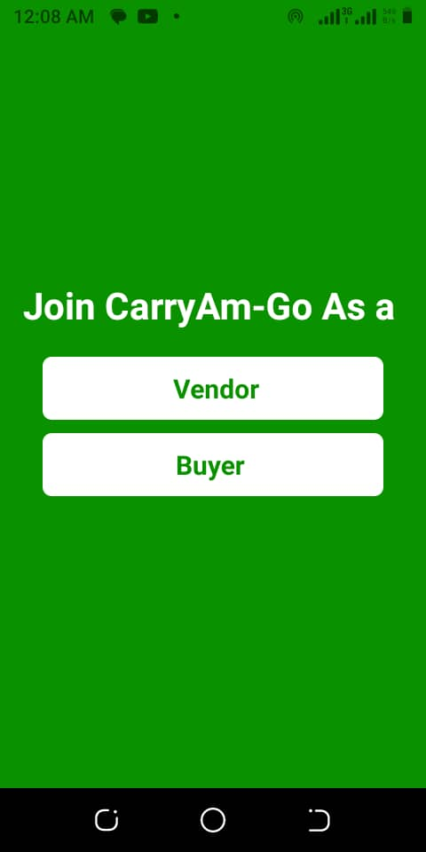 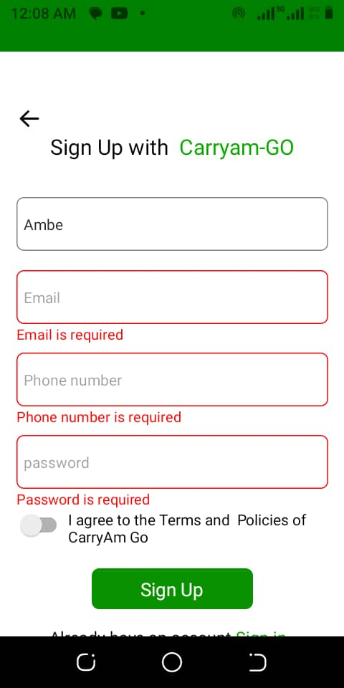 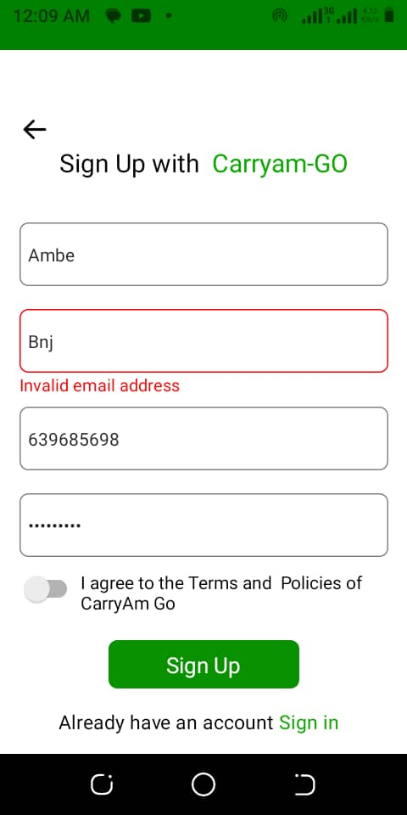

**Fig 11a: Join Screen Fig 11b: Error SignUp Screen1 Fig 11c: Error SignUp Screen2**

On the page that follows is the home screen for the vendor when he successfully signs up into our system CARYAMGO , and is given access the various products on in the market

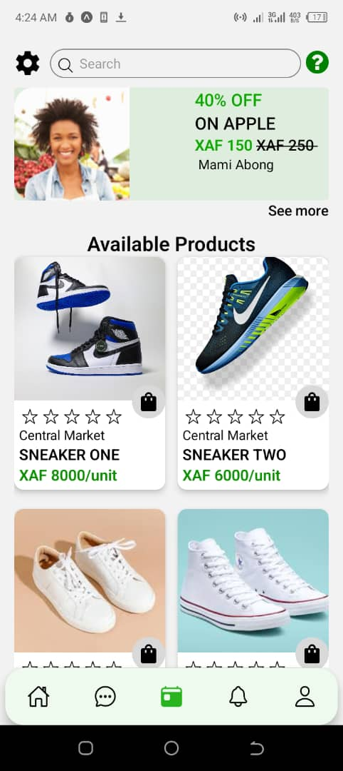 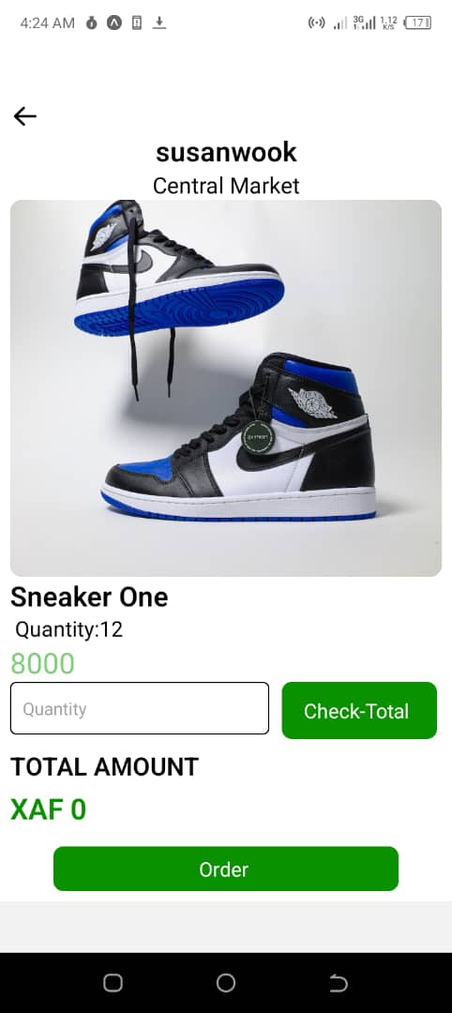 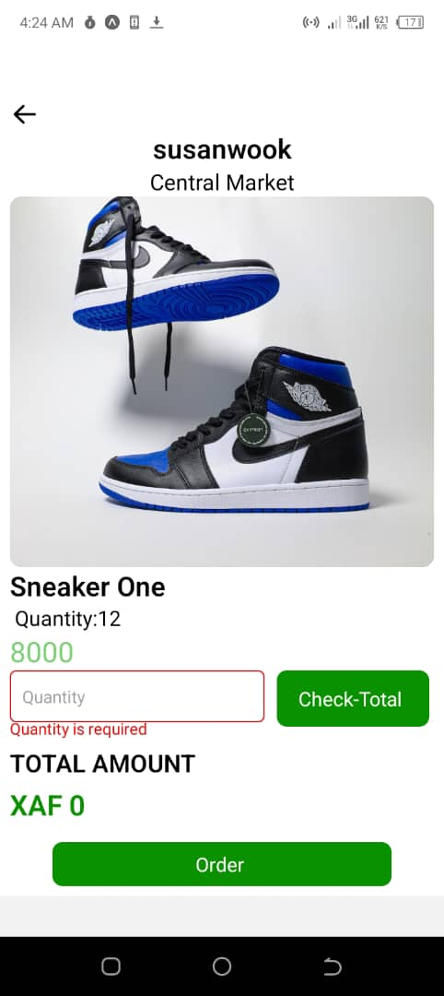

**Fig 11d: Vendor Home Screen Fig 11e: Vendor Order Screen Fig 11f: Vendor Error Order Screen**

The above images are figures that displays a selected product and the ability to place an order by giving the user the ability to see the total amount of money when a number of products is placed. in case no product is quantity is entered, an error is generated prompting the user to enter valid information. The next one shows what occurs when there’s no error

The figures that follow show the information displayed and the amount calculated when a user enters the number of products he wishes to order fromthe vendor.

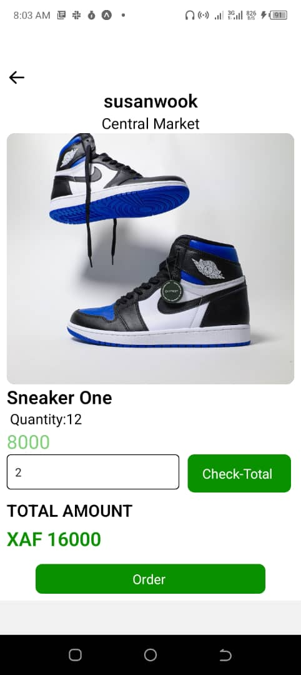 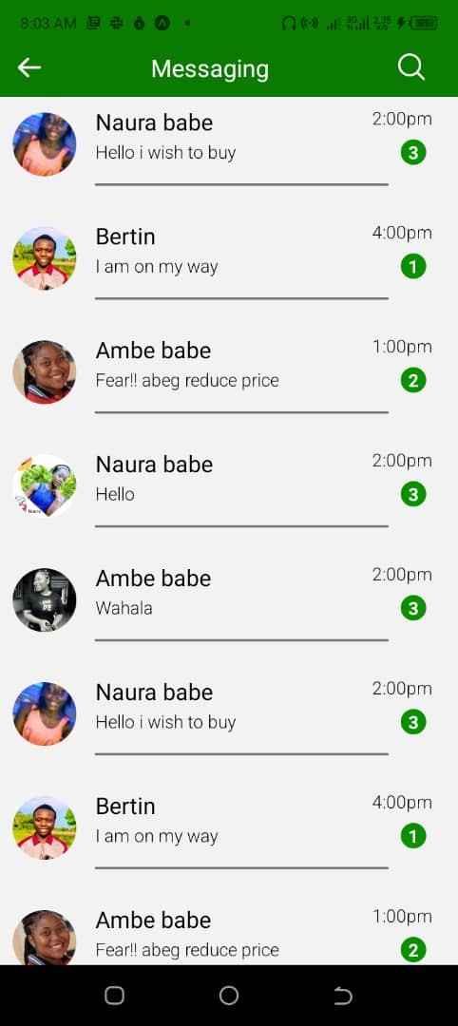

**Fig 11g: Vendor Calculation Order Screen Fig 11h: Messaging Screen**

When the order is placed , the buyer is redirected to the messaging section where he negotiates every possible negotiations with the Vendor . It is show in the figure below .

**Backend Implementation of Carryamgo Mobile Application**

The backend was developed using Django, a powerful Python web framework, to provide a robust and scalable solution for the application. This report will cover various aspects of the implementation, including the architecture, features, database management, API endpoints, testing, and deployment.

**Architecture Overview:**

The backend architecture of the Carryamgo mobile application follows a client-server model. It consists of a Django web server that handles incoming requests from the frontend and interacts with the database to process and retrieve data. The backend is responsible for user authentication, managing buyer and seller accounts, handling product orders, notifications, messaging, promotions, and database operations.

**Running the backend:**  
To run the backend we need to do the following :

1. We need to first clone the repo to our local repository
2. Next we run the virtual environment but first we open the cloned repo in our code editor like vscode then we open the terminal of the code editor and type the following command **source venv/bin/activate**
3. Next we install all the required libraries for the backend by using installing them from the **requirements.txt** file by running the following command **pip install -r requirements.txt**
4. Next after installing all the required libraries we configure the database with the following command on the terminal

**export DATABASE_URL=postgres://carryamgo_user:HXphEmory0tN6inON9Dmt9SfOdRsidKM@**[**dpg-ci6dp15gkuvvgceak0eg-a.oregon-postgres.render.com/carryamgo_0bcj**](http://dpg-ci6dp15gkuvvgceak0eg-a.oregon-postgres.render.com/carryamgo_0bcj)

1. Next we run the backend with the following command **python manage.py runserver** this then provide a link to the local server which is served either by **localhost** or **127.0.0.1**
2. Next we open the link on the local server where we can test the api endpoints locally, or we can insert data via post request using the api endpoints we created or via the admin dashboard.
3. To login as an admin you have to go the following link **localhost:8000/admin** then you proceed to login with the default credential we created which are username: **admin** password: **pass0000**

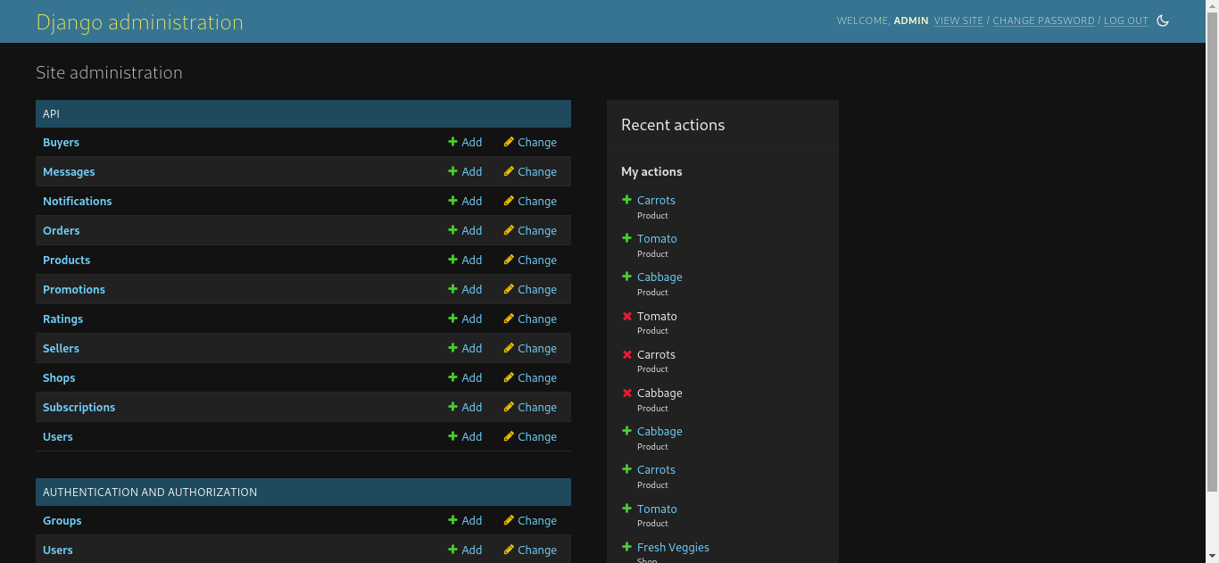

**Fig 12a: Admin dashboard for the local server**

1. And with that you can run the backend locally.
2. Since our application has been hosted on render you can access our api endpoints and the admin dashboard via this link [**https://carryamgo.onrender.com/**](https://carryamgo.onrender.com/)

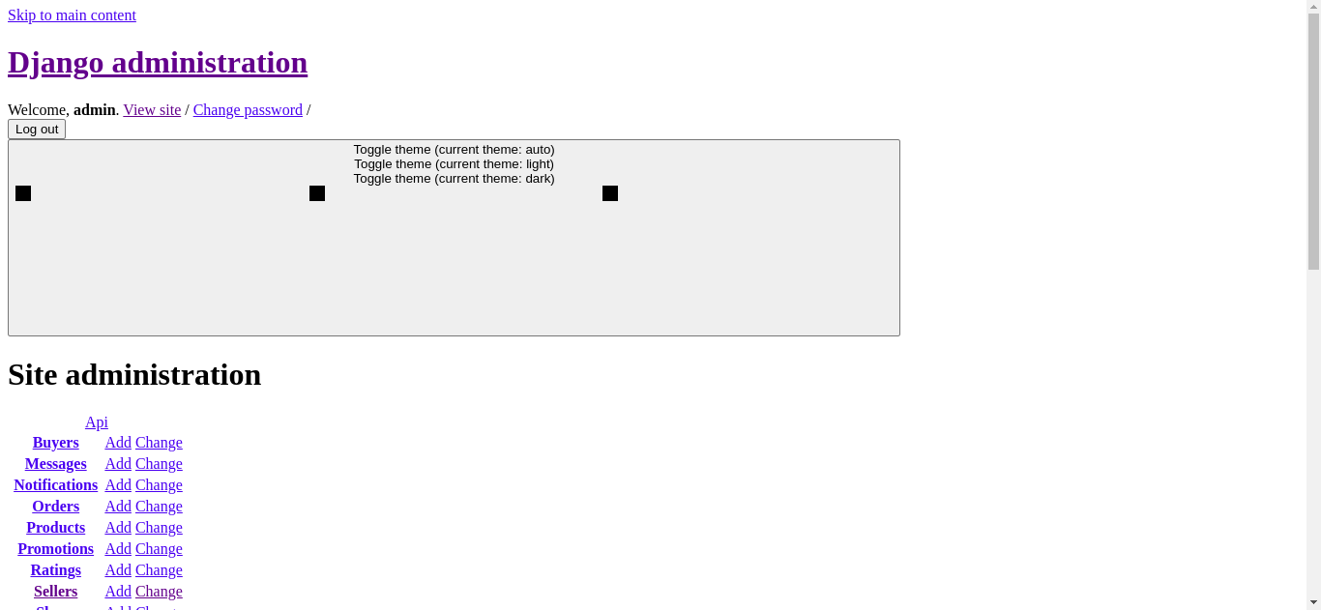

**Fig 12b: Admin dashboard for the deployed application on render**

1. To access the admin dashboard just add admin to the back or the last slash in the link above and to access any api endpoint you need to add **api/name_of_the_enpoint** eg **api/sellers** will give you all the api’s in our system

**Implemented Features:**

The following features were implemented in the Carryamgo mobile application backend

**a. User Management:**

User Registration and Login: Users can create their accounts and authenticate using credentials.

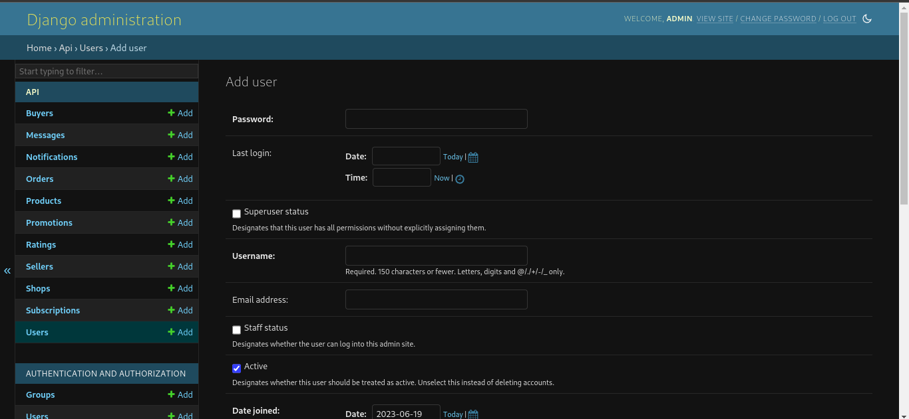

**Fig 12c: User management**

Account Types: The system supports two types of accounts, buyers and sellers.

**b. Buyer Features:**

Order Placement: Buyers can browse products and place orders for the desired items.

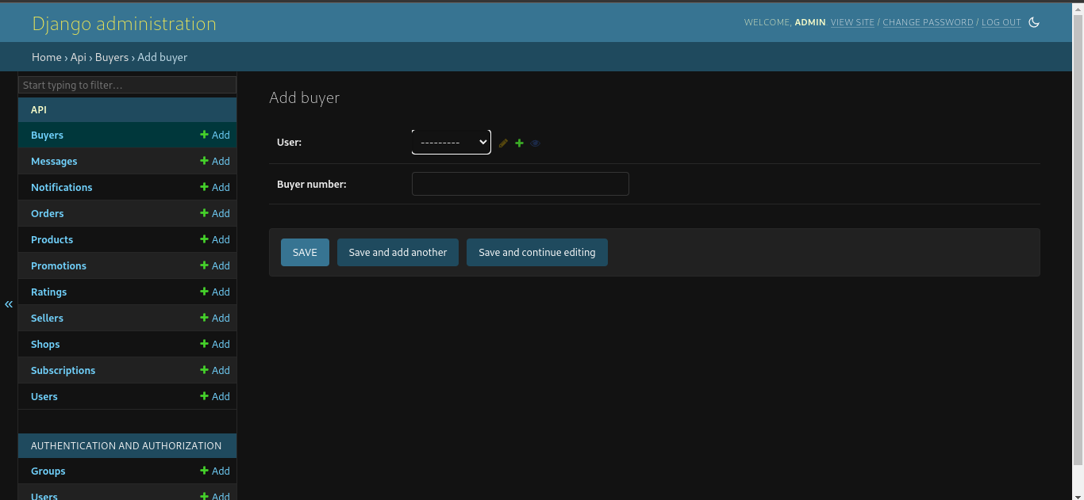

**Fig 12d: Buyer Features**

**Notifications:**

Buyers receive notifications for order updates and other important events.

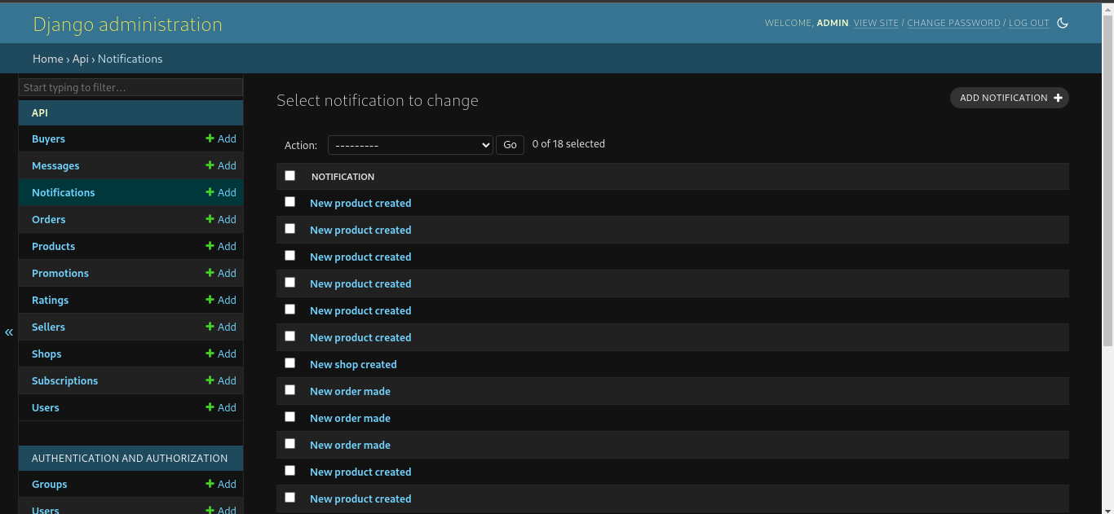

**Fig 12e: Buyer Notification Features**

**Messaging:**

Buyers can send messages to sellers for inquiries or order-related communication.

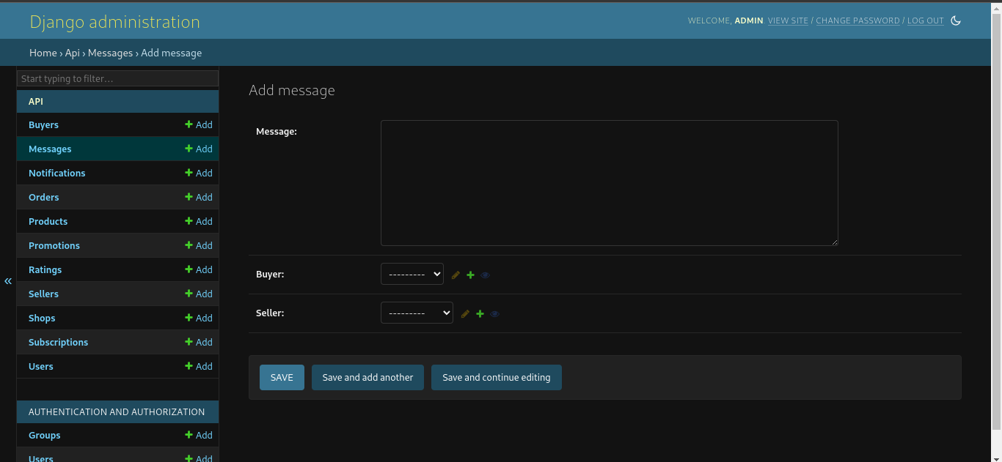

**Fig 12f: Buyer Messaging features**

**Rating:**

Buyers can rate sellers depending on the quality of the products

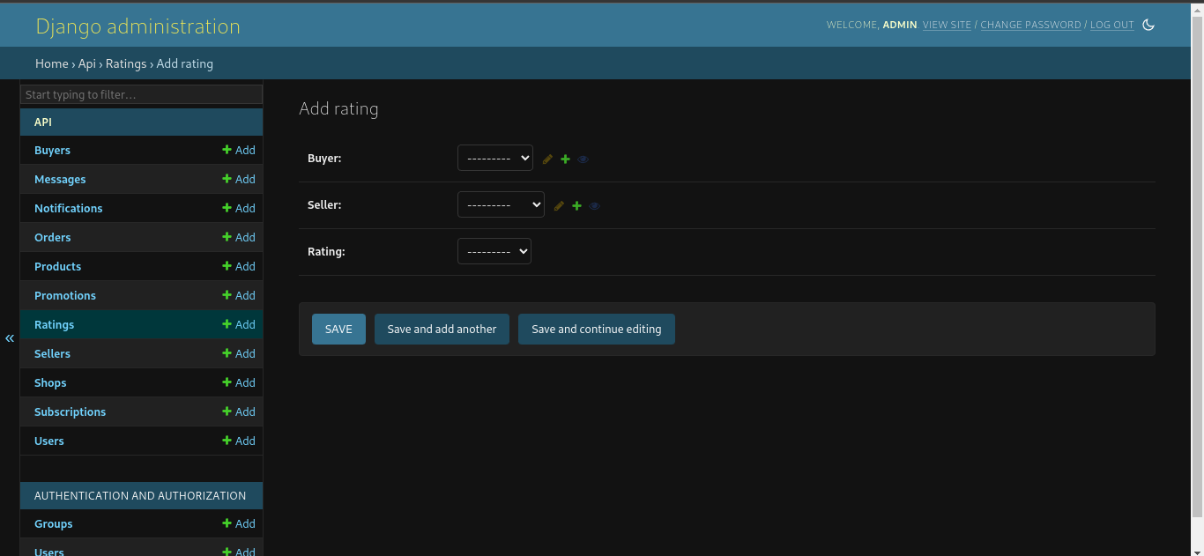

**Fig 12g: Buyer Rating feature**

**c. Seller Features:**

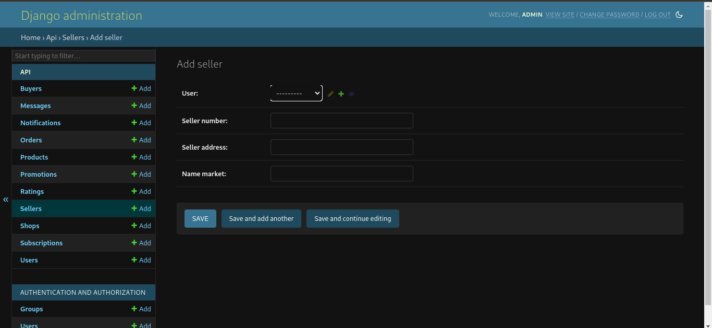

**Fig 12h: Seller features**

**Shop Creation:**

Sellers can create their shops to showcase their products.

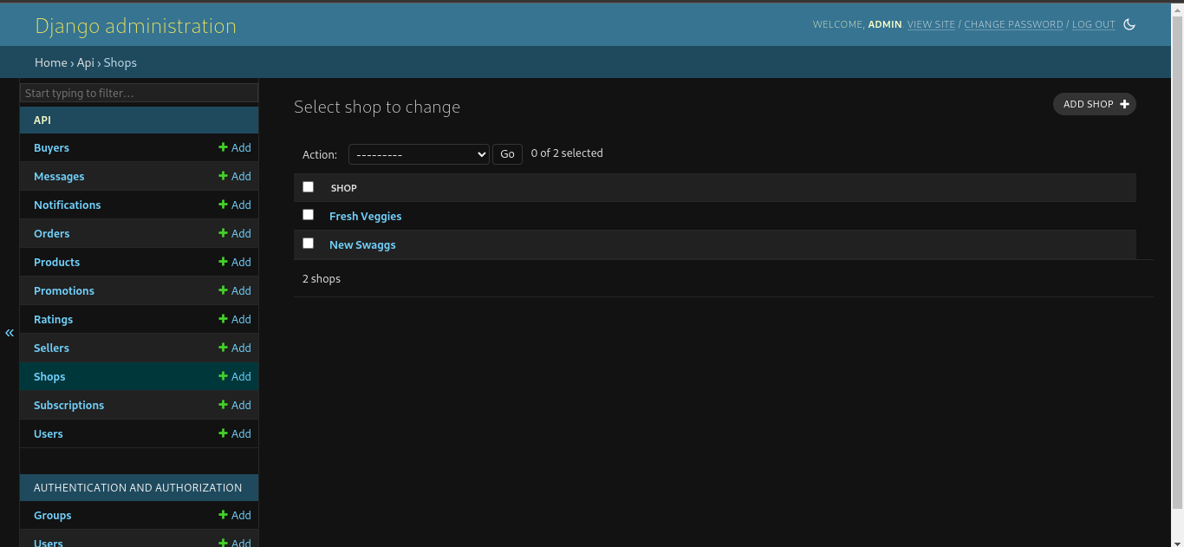

**Fig 12i: Shop creation**

**Product Management:**

Sellers can add, edit, and delete products in their shops.

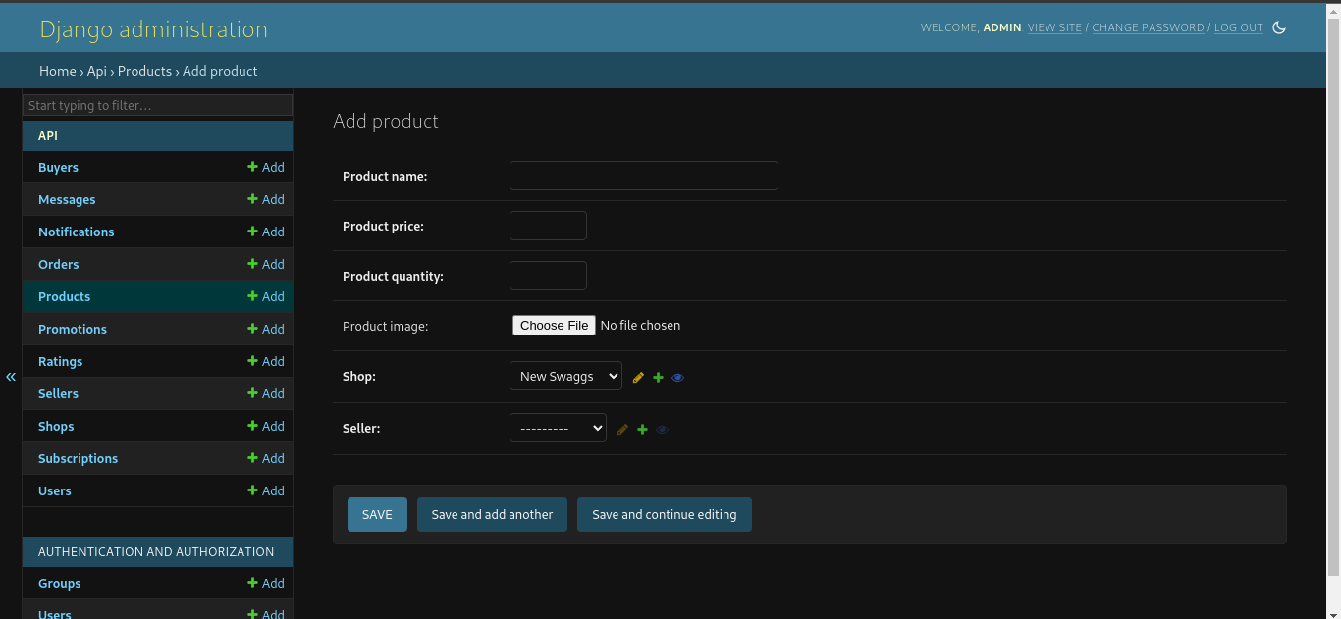

**Fig 12j: Product Management**

**Subscription Plans:**

Sellers can subscribe to different account plans to increase their inventory capacity.

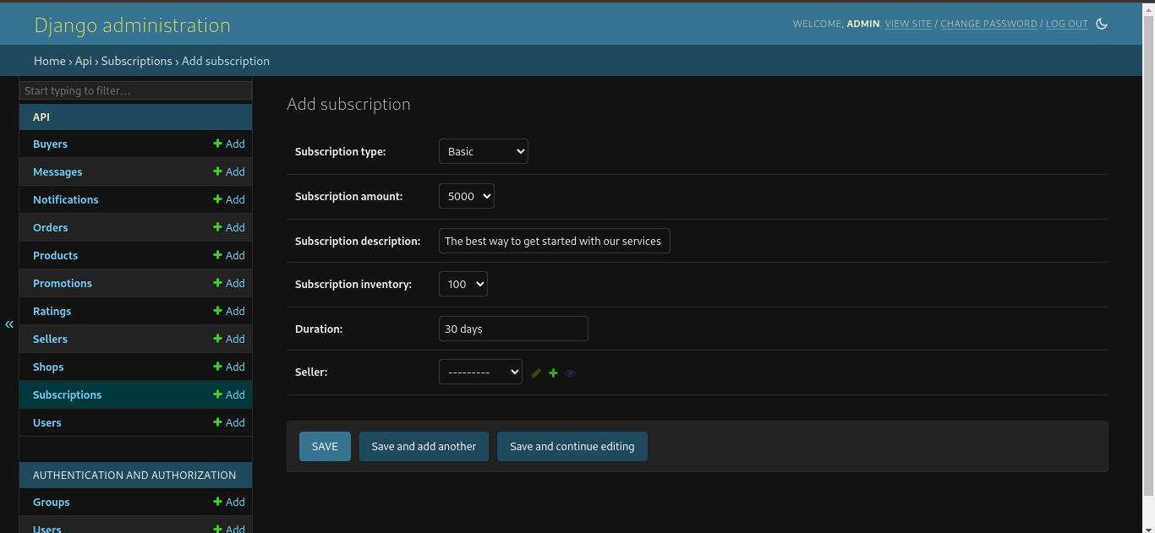

**Fig 12k: Subscription feature**

**Promotions:**

Sellers can create promotions to attract buyers and increase sales.

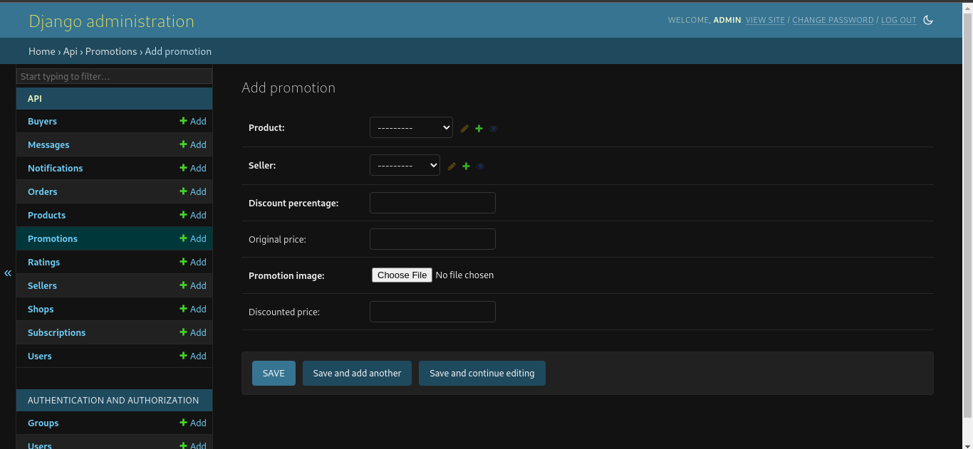

**Fig 12l: Promotion feature**

**Notifications:**

Sellers receive notifications for new orders, messages, and other events.



**Fig 12m: Seller Notification feature**

**Messaging:**

Sellers can communicate with buyers regarding orders or inquiries.



**Fig 12n: Seller Messaging feature**

**Backend Infrastructure:**

**a. Hosting:**

The backend of Carryamgo is hosted on Render, a cloud platform that provides a scalable and reliable infrastructure for running web applications.

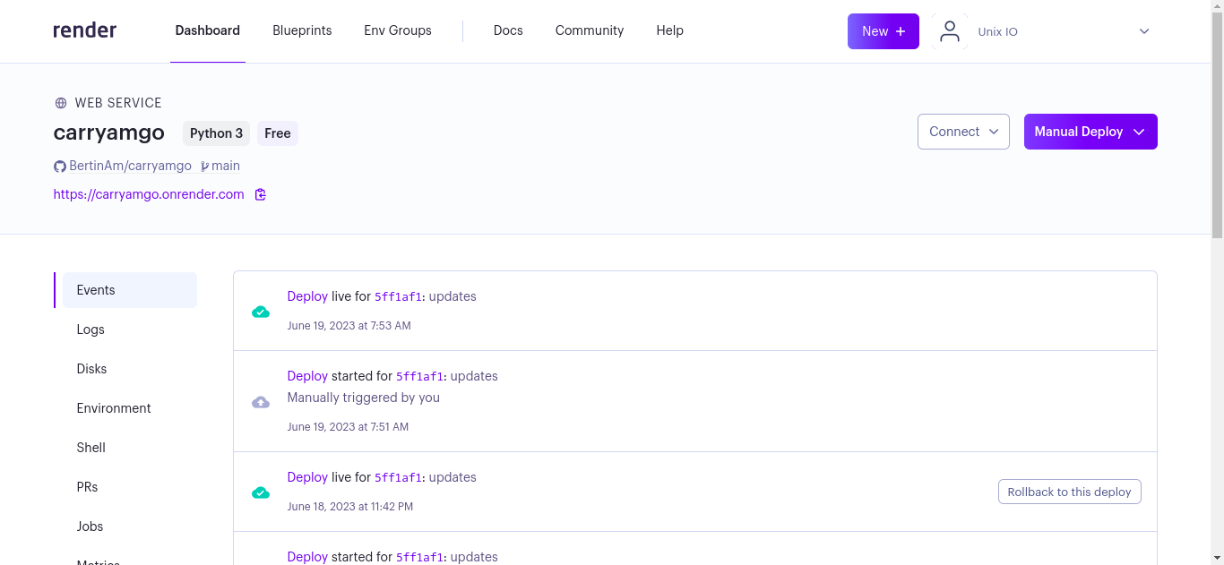

**Fig 13a: Hosted backend on Render**

**b. Virtual Environment:**

A virtual environment named "venv" was created to isolate the Python dependencies and ensure a consistent development environment.

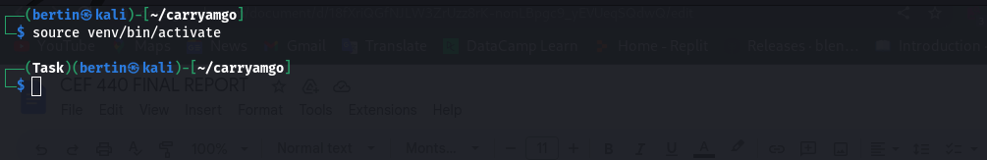

**Fig 13b: Activating the virtual environment**

**c. Libraries and Dependencies:**

The required libraries for the backend were listed in the "requirements.txt" file. These dependencies were installed within the virtual environment to manage the project's external dependencies effectively.

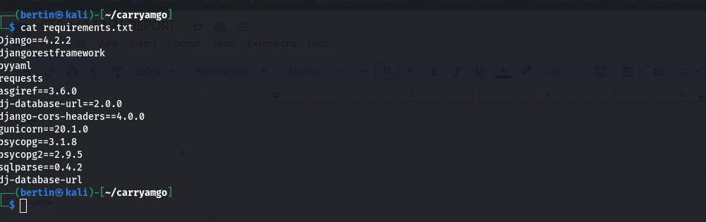

**Fig 13c: Requirements from the requirements.txt file**

**d. Database Management:**

The backend uses PostgreSQL, a robust and open-source relational database management system, to store and manage the application's data. The database schema was designed to accommodate the various models and their relationships.

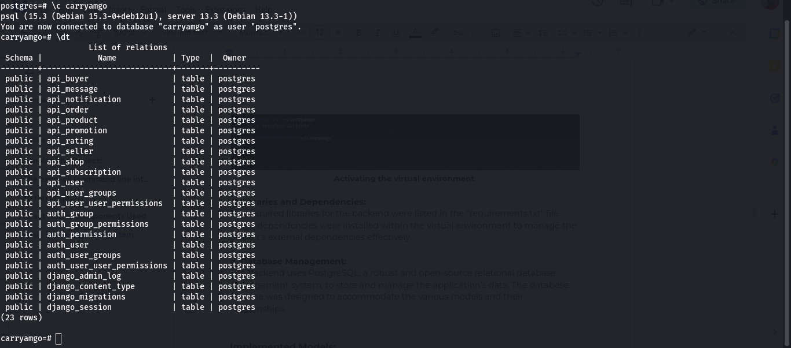

**Fig 13d: Database management**

**Implemented Models:**

The following models were created to represent different entities within the Carryamgo mobile application backend:

**a. Abstract User Model:**

This model extends Django's built-in AbstractUser model to provide a customizable user authentication system.

**b. Seller Model:**

This model represents the seller accounts and stores information related to sellers, such as contact details and subscription plan.

**c. Buyer Model:**

This model represents the buyer accounts and stores relevant information, including contact details.

**d. Order Model:**

This model represents the product orders placed by buyers and contains details such as the buyer, products ordered, and order status.

**e. Promotions Model:**

This model stores information about the promotions created by sellers, including the promotional offer, duration, and associated products.

**f. Product Model:**

This model represents the products available for sale and contains attributes like name, description, price, and seller information.

**g. Notifications Model:**

This model stores notifications sent to both buyers and sellers, including details like the sender, recipient, message, and timestamp.

**h. Shop Model:**

This model represents the shops created by sellers and includes attributes like shop name, description, location, and contact information.

**i. Messaging Model:**

This model facilitates communication between buyers and sellers and stores messages, sender, recipient, and timestamp.

**J. Rating Model:**

This model allows buyers to be able to rate sellers which helps improve credibility of the seller and improve sales.

**API Endpoints:**

The backend provides a set of API endpoints that allow the frontend to communicate with the server and perform various operations. These endpoints include:

1. User Registration and Login Endpoints:<http://carryamgo.onrender.com/>
2. Buyer and Seller Account Management Endpoints: <http://carryamgo.onrender.com/sellers> and <http://carryamgo.onrender.com/buyers>
3. Order Management Endpoints: <http://carryamgo.onrender.com/orders>
4. Product Management Endpoints: <http://carryamgo.onrender.com/products>
5. Shop Management Endpoints: <http://carryamgo.onrender.com/shops>
6. Subscription Plan Endpoints: <http://carryamgo.onrender.com/subscriptions>
7. Promotion Management Endpoints: <http://carryamgo.onrender.com/promotions>
8. Notification Management Endpoints: <http://carryamgo.onrender.com/notifications>
9. Messaging Endpoints: <http://carryamgo.onrender.com/messages>
10. Rating Endpoints: <http://carryamgo.onrender.com/ratings>

**Testing:**

To ensure the correctness and functionality of the backend, the Postman tool was utilized for testing the API endpoints. The endpoints were tested with various input scenarios to verify their behavior and validate the responses.

Some test performed with postman:

**Testing the buyers api endpoint**

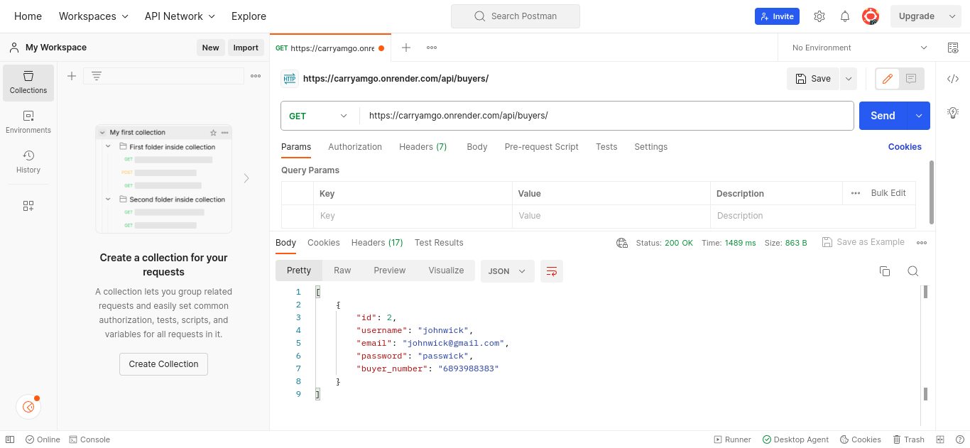

**Fig 14a: Testing the notifications endpoint**

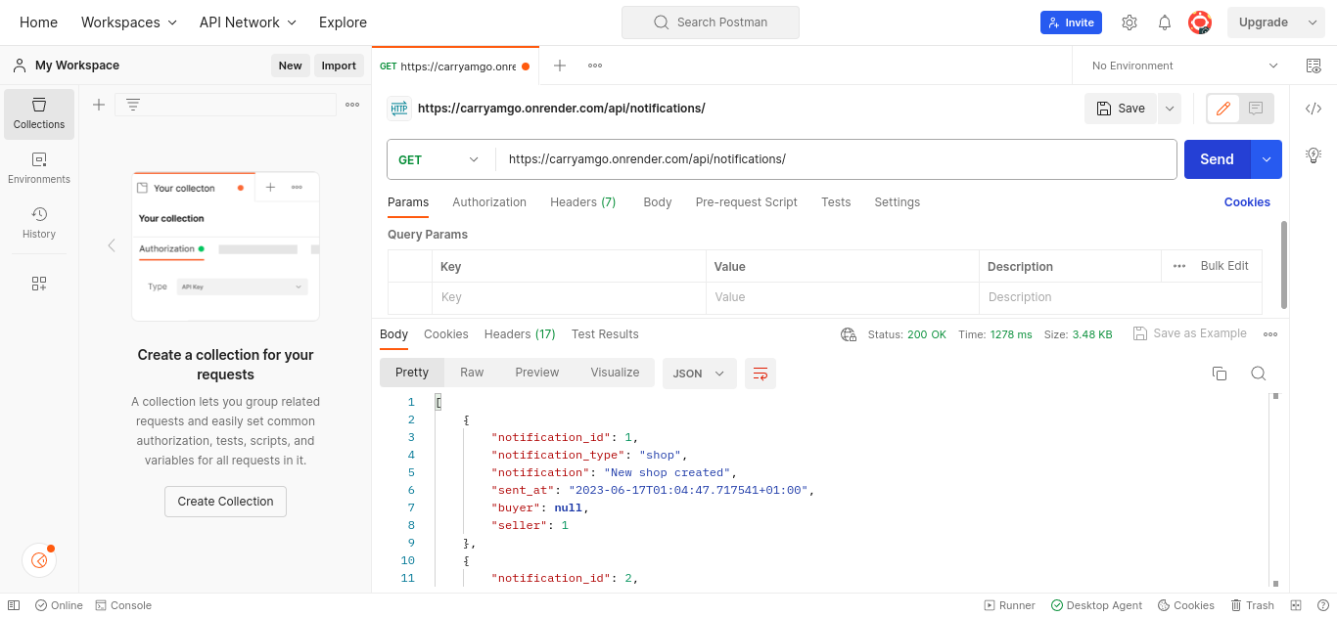

**Fig 14b: Testing the orders api endpoint**

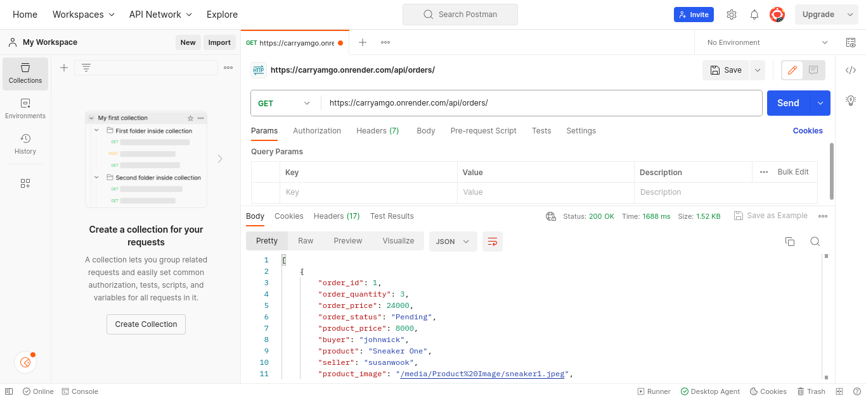

**Fig 14c: Testing the products api endpoint**

**CHAPTER5: CONCLUSION AND FURTHER WORKS**

**5.1. Summary of Findings**:

After the analyses, design and implementation of a market management system, a couple of findings were got which can be seen below

* The market management system effectively addresses the identified needs and requirements of the market, providing a comprehensive solution for managing the buying and selling process.
* The system's design and features support effective buyer-seller interactions, increase sales, and reduce costs, leading to improved efficiency and profitability for market participants.
* The global architecture of the solution ensures that the system operates effectively and efficiently across different regions and locations, while maintaining scalability, flexibility, and reliability.
* The system's integration with other systems and applications is seamless, allowing for easy data exchange and collaboration across different platforms.
* The resolution process is effective and fair, providing a structured approach for resolving issues or conflicts between buyers and sellers.
* The market management system makes a significant contribution to engineering and technology, incorporating state-of-the-art technologies and approaches to ensure its effectiveness and efficiency.

**5.2.** **Contribution to Engineering and Technology.**

* **Streamlined Market Operations:** The system streamlines the process of market management by providing a centralized platform for buyers and sellers. It eliminates the need for physical searches and manual inquiries, allowing users to access real-time information on product availability, prices, and location. This automation improves the overall efficiency of the market and reduces time wasted in searching for specific items.
* **Data-Driven Decision Making:** By providing buyers with comprehensive information about product availability, prices, and location, the system empowers them to make informed decisions. Buyers can compare prices, check item availability, and plan their visits to the market accordingly. This data-driven approach improves the decision-making process for buyers and increases their satisfaction.
* **Enhanced Market Visibility:** The system promotes transparency in the market by making information readily available to both buyers and sellers. Buyers can easily review prices, compare offerings, and assess the reputation of sellers through ratings and feedback. Similarly, sellers can showcase their products, set competitive prices, and attract the right customers. This transparency fosters fair competition and trust within the market ecosystem.
* **Increased Reach:** The Market Management System extends the reach of both buyers and sellers beyond geographical constraints. Buyers can explore different markets and search for desired items regardless of their location. Similarly, sellers can display their products to a wider audience, attracting customers who might not have been aware of their offerings otherwise. This expanded reach opens up new opportunities for both buyers and sellers, increasing market potential.
* **Technological Advancement:** The development and implementation of the Market Management System leverage advancements in mobile technology, database management, and user interface design. It showcases the application of engineering principles and technologies to create a user-friendly and efficient system. The system's architecture, algorithms, and integration of various features contribute to the advancement of engineering and technology in the field of market management.
* **Improved Customer-Seller Interaction:** The system facilitates seamless communication and interaction between buyers and sellers. Buyers can ask questions, seek clarification, and provide feedback directly to sellers through the app. This direct interaction enhances customer satisfaction and allows sellers to address customer inquiries promptly. The system promotes a customer-centric approach and strengthens the relationship between buyers and sellers.
* **Access to Information:** The system enhances information accessibility by providing customers with real-time data on product availability, prices, and locations. It empowers buyers to make informed decisions based on accurate and up-to-date information. Likewise, sellers can showcase their products and attract the right customers, enabling them to optimize their marketing strategies and improve sales.
* **Improved Efficiency and Productivity:** By digitizing market management processes, the system improves overall efficiency and productivity. It automates tasks such as product listing, inventory management, and order processing, reducing manual effort and minimizing errors. Sellers can efficiently manage their products, track sales, and focus on providing better customer service. Buyers can quickly find the desired products and plan their purchases, enhancing their shopping experience.

**5.3. Recommendations.**

The recommendations for an implemented market management system should aim to improve the system's effectiveness, efficiency, and usability, while also ensuring its scalability, security, and adaptability to meet the changing needs of the market. Some of them are

* Conduct regular user testing and feedback gathering to ensure that the system continues to meet the needs and requirements of the market participants.
* Implement additional features and functionality to further improve the user experience and support the buying and selling process. This may include features such as real-time data analytics, personalized recommendations, or mobile app integration.
* Enhance the system's security measures to ensure that sensitive data and transactions are protected from cyber threats or data breaches.
* Conduct regular performance testing and optimization to ensure that the system continues to operate effectively and efficiently, even as the number of users and transactions increases.
* Explore opportunities for integration with other systems and applications to support cross-platform data exchange and collaboration.
* Provide ongoing training and support to market participants to ensure that they are able to effectively use the system and take advantage of its features and functionality.
* Consider the potential for expansion into new markets or regions, and ensure that the system is designed to support scalability and adaptability to meet the specific requirements of different locations.

**5.4. Difficulties Encountered.**

Building a mobile app for a market management system can be complex and challenging, requiring careful planning, design, and testing to ensure its effectiveness and usability.

* **Integration with existing systems:** Integrating the mobile app with existing systems used by the market participants, such as customer relationship management (CRM) or enterprise resource planning (ERP) systems, was challenging. The mobile app needed to be able to access and exchange data seamlessly with these systems to provide a consistent and reliable experience for the user.
* **User interface design:** Designing a user-friendly and intuitive interface for the mobile app was difficult, particularly when dealing with complex features and functionality. The app needed to be designed to accommodate the smaller screen size of mobile devices, while still providing easy access to all the necessary features and information.
* **Cross-platform compatibility:** Ensuring that the app works effectively across different operating systems, such as iOS and Android, was quite challenging. The app needed to be tested extensively on different devices and operating systems to ensure compatibility and usability.
* **Security concerns:** Ensuring the security of the app and the data it handles was critical. The app needed to be designed with robust security features to protect against cyber threats, such as hacking, malware, and data breaches.
* **Getting users:** The app was expected to be user friendly nut it was quite difficult to get the target users of the system in the analysis phase.
* **User adoption:** Encouraging market participants to adopt the mobile app was challenging, particularly as they are used to using traditional methods for buying and selling. The app needs to be marketed effectively and provide clear benefits and incentives for users to switch to this new method.

**5.5 Further Works.**

Some possible directions for further work to improve the design and implementation of the market management system are:

* **User Feedback Feature:** here we talk of implementing a user feedback feature to allow customers to provide reviews for products and sellers, helping buyers make informed decisions.
* **Price and Quality Comparison Feature:** adding a feature that allows customers to compare the prices and quality of different products from different sellers in the market. This would help customers make informed decisions and save money and time.
* **Enhanced Search Functionality:** the search functionality should be improved by incorporating advanced filters, autocomplete suggestions, and search algorithms to improve the accuracy and efficiency of product searches.
* **Geolocation Services Integration:** geolocation services should be added to provide real-time distance and directions of sellers' locations, allowing customers to filter search results based on proximity.
* **Analytics and Reporting Tools:** Incorporate analytics tools to track user behavior, generate reports, and provide personalized recommendations for both buyers and sellers.
* **Multilingual Support:** Add multilingual support to cater to a wider user base, allowing users to switch between languages and enabling sellers to create product listings in different languages.
* **Offline Mode Feature:** Develop an offline mode feature for customers to access previously viewed product information and seller details even without an internet connection.
* **Scalability and Performance:** The system should be scalable to accommodate growth in the number of buyers and sellers. The system should be able to handle a large volume of transactions and data.

**References:**

* Kim, J., Park, J., Kim, H., & Kim, D. (2019). A mobile app for a smart agricultural market management system: A usability study. Computers and Electronics in Agriculture, 155, 104870.
* Liu, Y., Wang, X., & Liu, J. (2020). A mobile app for a smart campus market management system: A system testing and user feedback analysis. Journal of Retailing and Consumer Services, 54, 102224.
* Oyelere, B. L., & Kruger, M. C. (2020). A mobile app for a smart fish market management system: A prototype testing and user acceptance testing. Journal of Retailing and Consumer Services, 53, 102182.
* Alam, S., & Islam, M. R. (2021). A mobile-based smart market management system for farmers and consumers: A case study in Bangladesh. Sustainability, 13(1), 192.
* Arunkumar, G., & Manikandan, N. (2020). A mobile app for smart market management system for fruits and vegetables. International Journal of Innovative Technology and Exploring Engineering, 9(8), 4347-4353.
* Boateng, M., & Otoo, J. A. (2020). Smart market management system for local food vendors in Ghana. International Journal of Scientific Research in Computer Science, Engineering and Information Technology, 5(3), 176-183.
* Dahmash, M., & Alzoubi, M. M. (2021). A mobile-based smart market management system for agricultural products: A case study in Jordan. International Journal of Information Technology and Management, 20(1), 85-96.

**Appendices**

Appendix 1: Other sequence diagrams

**Create an Account**

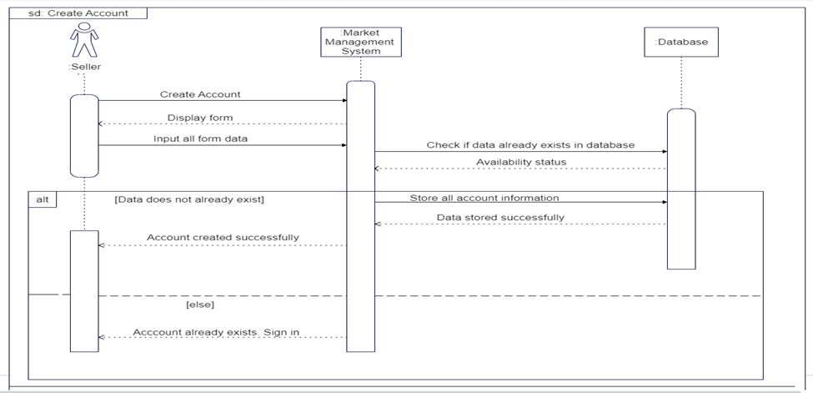

**Forgot Password**

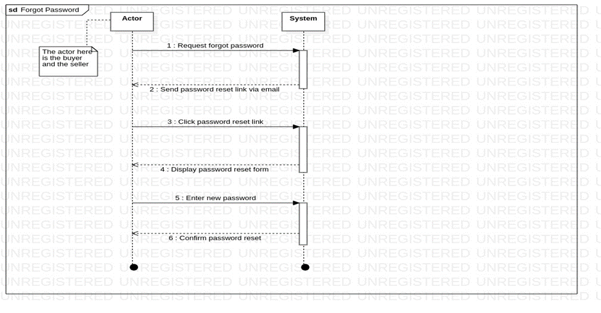

**Rate Vendor**

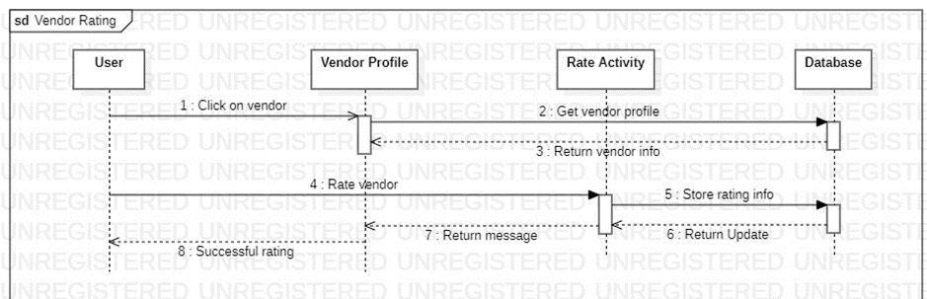

**Messaging**

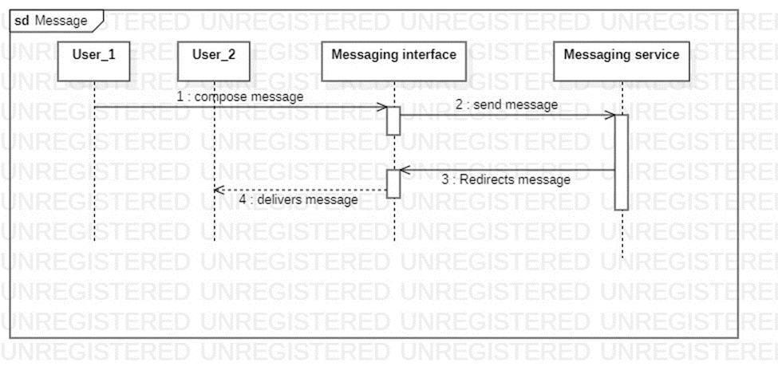

**Customer Support**

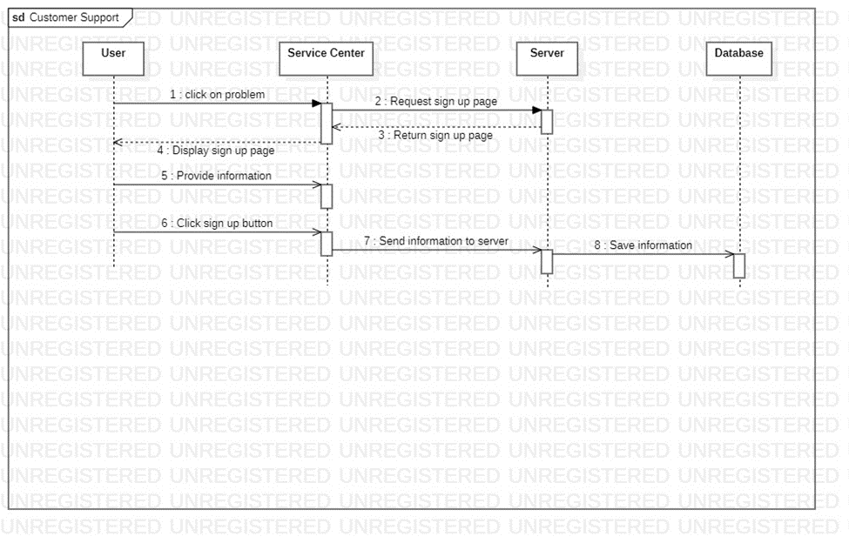

**Receive Market Update**

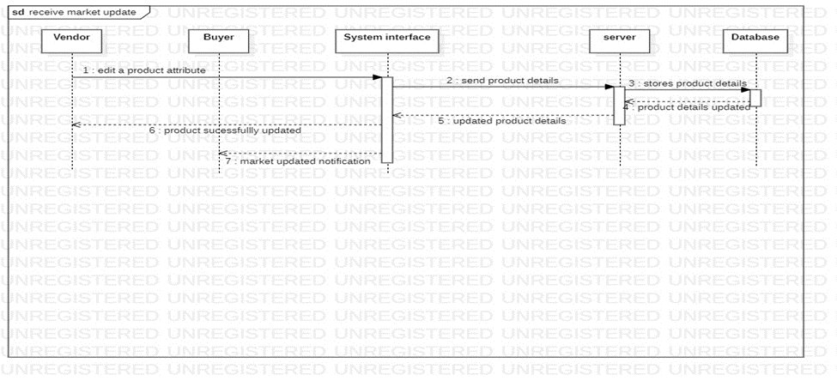

**Search Products**

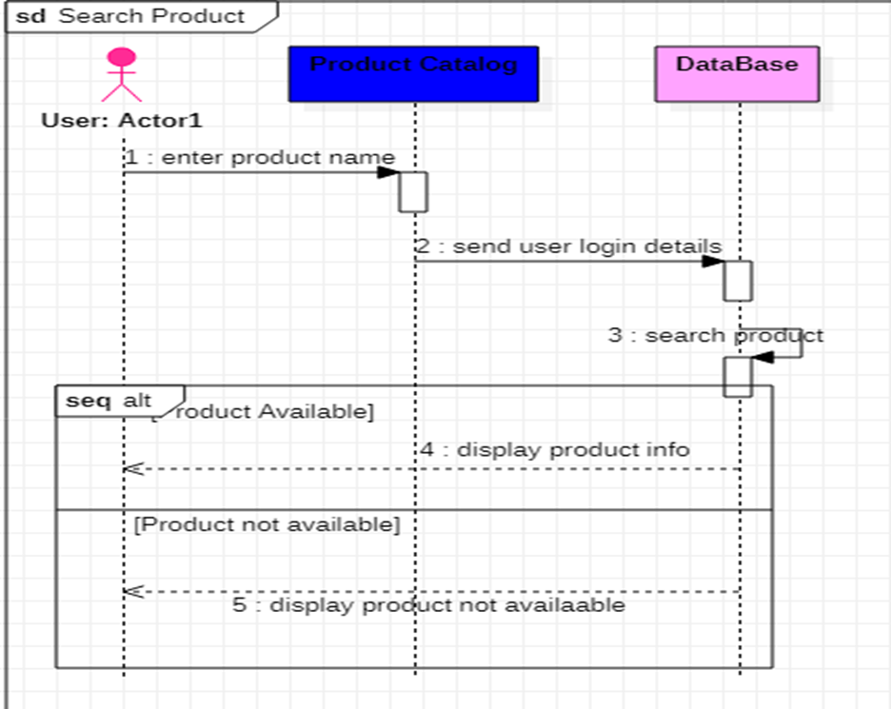

**View Seller List**

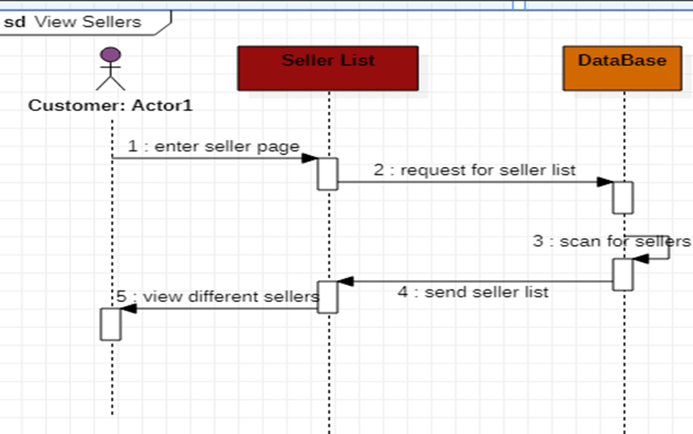

**Search Sellers**

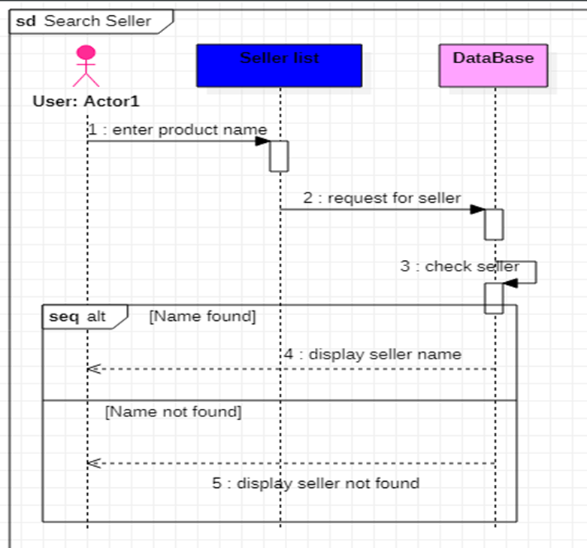

**View Seller Details**

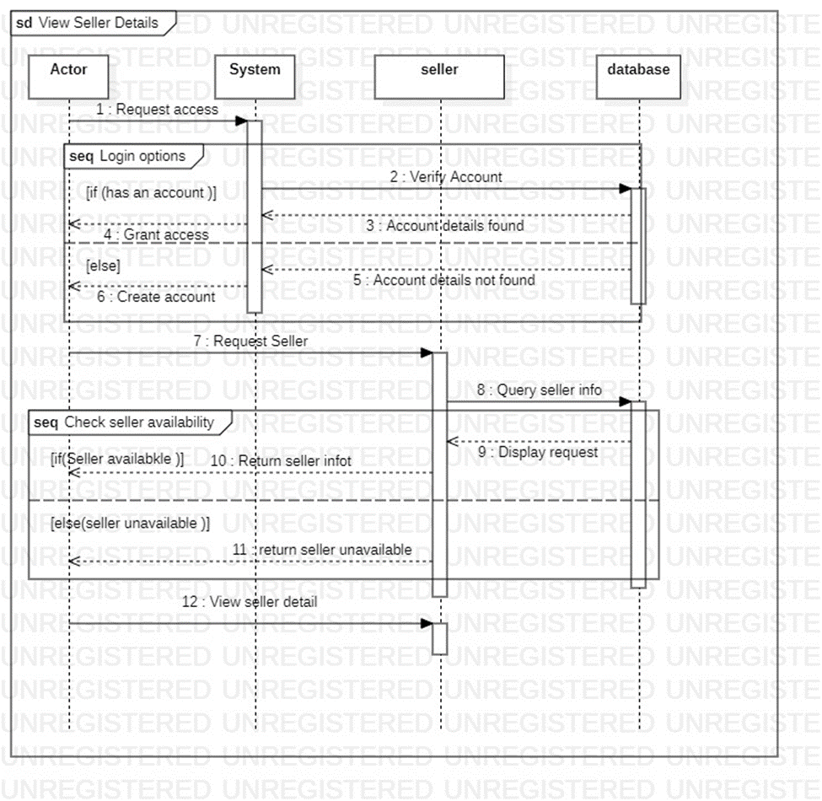

**Add Product**

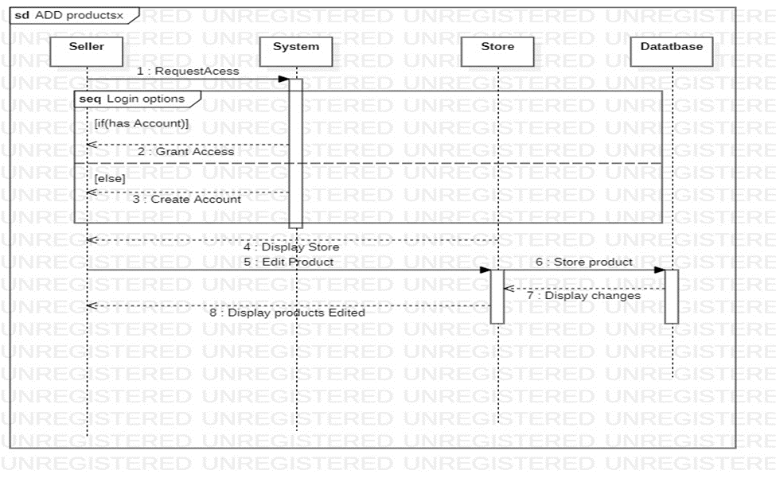

**Edit Product**

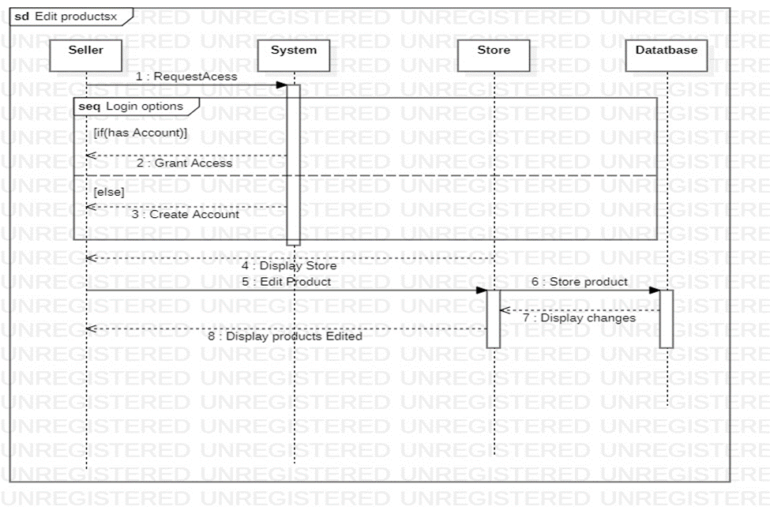

**Remove Product**



**Appendix 2: Seller Activity diagram**

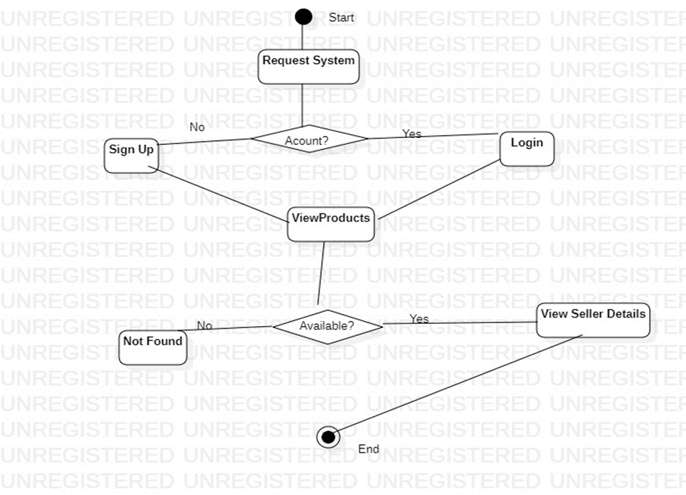

Appenix 3: Usecase scenarios

|  |  |
| --- | --- |
| **Use Case 1** | **Create Account** |
| Actors | Seller, Buyer, Administrator |
| Preconditions | None |
| Postconditions | The actor has successfully created a new account |
| Flow of Events | 1. The actor selects the "Create Account" option on the system interface.  2. The system presents the account creation form, which includes fields for username, password, email, and phone number.  3. The actor enters the required information into the form and submits it.  4. The system verifies the entered information and creates a new account for the actor.  5. The system displays a confirmation message to the actor. |
| Includes | authentication |
| Extensions | validation error |

|  |  |
| --- | --- |
| **Use Case 2** | **Login** |
| Actors | Seller, Buyer, Administrator |
| Preconditions | The user must have an account in the system |
| Postconditions | The user is authenticated and granted access to their respective dashboard |
| Flow of Events | 1. The user clicks on the login button on the website.  2. The system displays the login page, prompting the user to enter their username and password.  3. The user enters their username and password and clicks the "login" button.  4. The system authenticates the user's credentials by checking them against the stored user data.  5. If the authentication is successful, the system grants the user access to their respective dashboard.  6. If the authentication fails, the system displays an error message and prompts the user to try again. |
| Includes | Authenticate |
| Extensions | Validation error |

|  |  |
| --- | --- |
| **Use Case 3** | **Forgot Password** |
| Actors | Seller, Buyer, Administrator |
| Description | This use case helps users generate a new password after email authentication if the previous password has been forgotten |
| Preconditions | The user already has an account created |
| Postconditions | New password generated |
| Flow of Events | 1. User clicks forgot password button  2. Password reset link is sent to the email  3. User clicks the link in the email and the password reset form is displayed  4. User enters a new password  5. System stores a new password and sends a success message. |
| Includes | None |
| Extensions | None |

|  |  |
| --- | --- |
| **Use Case 4** | **Rate System** |
| Actors | Seller, Buyer, Administrator |
| Description | 1. The rate system allows buyers to rate and review products they have purchased from sellers on the online marketing portal.  2. The system captures and stores the rating and review data in the database for future reference.  3. The seller can view the ratings and reviews of their products, as well as respond to reviews.  4. The buyer can update or delete their reviews within a certain time frame.  5. The administrator can view and manage all reviews and ratings on the system, including deleting inappropriate reviews or suspending users who violate the platform's policies. |
| Includes | None |
| Extensions | None |

|  |  |
| --- | --- |
| **Use Case 5** | **Subscribe** |
| Actors | Seller, Buyer, Administrator |
| Description | This use case describes the process of subscribing to the online marketing portal to access the features and services provided by the system. |
| Preconditions | The user is not subscribed to the online marketing portal. |
| Postconditions | The user is subscribed to the online marketing portal and has access to the features and services provided by the system. |
| Flow of Events | 1. The user navigates to the online marketing portal.  2. The user clicks on the "Subscribe" button.  3. The system prompts the user to register or login to their existing account.  4. If the user doesn't have an account, they can register by providing their personal information and creating a new account.  5. If the user has an account, they can log in using their username and password.  6. Once logged in, the user can manage their products, sell products, buy products, and access admin management features.  7. The user can also search for products, compare prices, and add products to their cart. |
| Includes | Register |
| Extensions | None |
| Alternate Flow | If the user enters invalid login credentials, the system displays an error message and prompts the user to try again.  If the user encounters technical difficulties during the subscription process, the system displays an error message and prompts the user to contact customer support for assistance. |

|  |  |
| --- | --- |
| **Use Case 6** | **Messaging** |
| Actors | Seller, Buyer |
| Description | This use case represents the messaging functionality within the online marketing portal system. It allows communication between sellers, buyers, and administrators. |
| Preconditions | The seller and buyer must be logged in to the system. |
| Postconditions | The seller has messaged the buyer and vice versa |
| Includes | Send Message: The ability for sellers and buyers to send messages to each other. |
| Extensions | Receive Message: Sellers, buyers, and administrators can receive messages from other users. |

|  |  |
| --- | --- |
| **Use Case 7** | **Customer Support** |
| Actors | Buyer, Seller, Administrator |
| Description | This use case describes the process of providing customer support to users of the online marketing portal. |
| Preconditions | The user has contacted the customer support service of the online marketing portal. |
| Postconditions | The user's issue or inquiry has been resolved or escalated to the appropriate party. |
| Includes | None |
| Extensions | None |

|  |  |
| --- | --- |
| **Use Case 8** | **Receive Market Update** |
| Actors | Seller, Buyer, Administrator |
| Description | This use case describes the process of receiving market updates, which includes information about new products, prices, and locations. |
| Preconditions | 1. The Online Marketing Portal is running.  2. The Seller, Buyer, or Administrator is logged in. |
| Postconditions | 3. The Seller, Buyer, or Administrator is informed about the market updates.  4. The market updates are displayed on the Online Marketing Portal. |
| Flow of Events | 1. The system detects new market updates.  2. The system sends notifications to the Seller, Buyer, and Administrator.  3. The Seller, Buyer, or Administrator receives the notification.  4. The Seller, Buyer, or Administrator reviews the market update. |
| Includes | None |
| Extensions | None |

|  |  |
| --- | --- |
| **Use Case 9** | **View Product List** |
| Actors | Buyer, Seller, Administrator |
| Preconditions | 1. The Buyer is registered and logged into the system.  2. The Seller has added their products to the system.  3. The Administrator has approved the Seller's products. |
| Postconditions |  |
| Flow of Events | 1. The Buyer selects the "View List of Products" option from the system menu.  2. The system displays a list of available products and their prices, sorted by category or seller.  3. The Buyer can filter the list by category, location, or price range.  4. The Buyer selects a product from the list to view its details and location.  1. 5. The system displays the product details, including the name, description, price, location, and seller contact information. |
| Includes | display error |
| Extensions | 1. Purchase product  2. manage product list |

Appendix 4: other designed screens

